Civilian Jammer Detection and Geolocation Algorithms

Document: D19756

**R****EVISION HISTORY**

|  |  |  |  |  |  |
| --- | --- | --- | --- | --- | --- |
|  |  | **EFFECT** |  |  | |
| **REV** | **DOC#** | **DATE** | **DESCRIPTION** | **TITLE** | **NAME** |
| 0A | D19756 | 26 Nov 2014 | Initial Release | Research Manager/Fellow | J.B. Schleppe |
|  |  |  |  |  |  |
|  |  |  |  |  |  |
|  |  |  |  |  |  |
|  |  |  |  |  |  |

**RESTRICTED PROPRIETARY INFORMATION**

The information disclosed herein is the exclusive property of NovAtel Inc. and is not to be disclosed without the written consent of NovAtel Inc. No part of this publication may be reproduced or transmitted in any form or by any means including electronic storage, reproduction, execution or transmission without the prior written consent of NovAtel Inc. The recipient of this document by its retention and use agrees to respect the security status of the information contained herein.

**This document is intended for limited circulation.**

The information contained in this document is subject to change without notice and should not be construed as a commitment by NovAtel Inc. unless such commitment is expressly given in a covering document.

© Copyright NovAtel Inc. (2014)

**Table of Contents**

1 Introduction 6

1.1 Research Project Timeline 6

2 Acronyms 8

3 Test System Configurations 8

3.1 Prototype Receivers 9

3.1.1 FireHose Data Collection System 9

3.1.1.1 Digital GNSS Front End 11

3.1.1.1.1 OEMV-1DF GPS Receiver 11

3.1.2 Sprinkler Data Collection System 12

3.1.2.1 OEM628 Sprinkler Receiver 13

3.1.3 Chip-Scale Atomic Clock (CSAC) 13

3.1.4 NovAtel GPS-702-GG Antenna 14

3.2 Prototype Software 14

3.2.1 Perforce Repository 15

3.2.2 FireHose Firmware 16

3.2.3 Sprinkler Firmware 16

3.2.4 PC Based Command-Display Utility 16

3.2.5 Linux Based Data Collection Utility 16

4 Jammer Detection with Automatic Gain Control 17

5 JAMMER IDENTIFICATION 25

5.1 Characteristics of Civilian Jammers 25

5.1.1 Measuring Chirp Rate 29

5.2 Determining Chirp Characteristics – PulseTracker Software 31

6 Geolocation of Civilian Jammers 34

6.1 Datum and Ellipsoid 37

6.1.1 Reduction of Measurements to the Ellipsoid 38

6.2 Universal Transverse Mercator Mapping Plane 40

6.2.1 Conversion from Latitude and Longitude to Northing and Easting 40

6.2.2 Conversion from Northing and Easting to Latitude and Longitude 42

6.2.3 Reduction of Measurements to the UTM Mapping Plane 43

6.3 Measurements 45

6.4 TDOA Measurements 45

6.4.1 Theoretical Time Differences of Arrival 46

6.4.2 TDOA Measurements from Monitor A to Monitor B using Cross Correlation 47

6.4.2.1 Discriminator 52

6.4.2.2 Examples of Conversion from Cross Correlation to TDOA 55

7 Geolocation 56

7.1 Using the TDOA for Geolocation 56

7.2 Monitor Station Geometry and Jammer Location Accuracy 59

7.3 Geolocation Test Results 64

8 Conclusions and recommendations 70

8.1 Recommendations 70

8.2 Limitations 71

9 References and APPLICABLE DOCUMENTS 72

9.1 Non-NovAtel Documents 72

9.2 NovAtel Documents 72

10 AppendixA – Alternate method of computing UTM Scale Factor for Distances 74

# Introduction

The objective of this research was to gain a better understanding of jammers, their detection and geolocation.

This report summarizes the design details and algorithms for jammer detection using Automatic Gain Control (AGC) measurements and for jammer geolocation using Intermediate Frequency (IF) I/Q data. Described are the hardware, software, detection and geolocation algorithms. Also discussed are some of the problems encountered and areas for future investigation. In summary, the two systems developed during the research project are capable of detecting a single civilian jammer at distances of up to 1 km and can geolocate the jammer to within 10 m with standard deviations less than 1.5 m. It was found that less than 1 ms of 1 bit IF I/Q common data between 4 monitor sites is all that is required to determine the position of the jammer.

## Research Project Timeline

At the beginning of this research the objective was to detect and geolocate civilian jammers. We only had a rough idea on how to detect the jammers and how geolocate them with TDOAs. The FireHose IF I/Q receiver was already built, but no requirements were set in terms of data bit size, bandwidth or receiver placement for jammer geolocation. Along the way to completing this research the team learned about civilian jammers, their power and effect on GNSS receivers, their characteristics and the frequency of their use near NovAtel. As with many things in the navigation and positioning world, we also learned that data timing is crucial. By the end of the research we knew how to consistently detect jammers in real-time using the AGC from NovAtel’s receivers and how to geolocate a moving civilian jammer using the IF data from a continuous data streaming receiver such as the FireHose or a burst data collector such as the OEM628 Sprinkler.

Two different systems were developed for jammer detection and geolocation. The first based on the FireHose receiver used GPS L1 IF data collected at 5 Msps and containing 8 bits of data. Data from three FireHose receivers was collected during jamming trials at Whitesands in the autumn of 2012. During this trial we discovered that the FireHose receivers quickly lost timing during jamming but we were able to briefly correlate observations between receivers to form TDOA measurements to the jammer. Receiver geometry with respect to the jammer was poor during the test resulting in only approximate geolocation of the jammers.

The ability to maintain predictable timing during jamming was identified as one of the problems with the current system. Investigation into clocks showed that a suitable Chip Scale Atomic Clock was available from Symmetricom. An API was developed for the FireHose to steer the CSAC. This was integrated with the FireHose receiver and a rack-mount Windows computer for data collection. The data collected by the system was later downloaded and post-processed to compute the position of the civilian jammer. The first post-processing software to compute the TDOA measurements using correlation techniques took over 2 hours to process 5 minutes of data from 4 stations. The slow processing time was considered a bottle neck and so a side project took the TDOA correlation software and adapted it to use a GPU to assist in processing. Project completion saw processing times reduced from 2 hours to 3 minutes for processing 5 minutes of data from 4 FireHose monitor stations.

The second test of the system was completed at CFB Petawawa during the spring of 2013. The FireHose system was tested over two days with five different civilian jammers in static and dynamic scenarios. Positioning of four of the five static civilian jammers was within 10 m of the control coordinates with standard deviations of 1.5 m. Moving jammer results were comparable so long as the jammer remained within the FireHose monitor array. The further away the jammer moved from the monitor array, the worse the positioning become. This was easily explained as dilution of precision based on the relative geometry of the jammer and stations.

Following the Petawawa tests, work began on a new digital receiver based on the OEM628. During the fall of 2013 and the spring of 2014 a new data sensor was developed by Pat Fenton around the OEM628 receiver. Onboard the MINOS6 was a feature for outputting IF data at 1 bit. Software was written onboard the OEM628’s processor to capture a burst of this data coincident with the receivers 1pps. Tests showed that a burst of 5.2 ms could be captured and output from the receiver without compromising its normal positioning functions. It was thought that this may be a good platform for civilian jammer data capture since: 1) the volume of data was significantly smaller than that from the FireHose; 2) the IF data was measured coincident with the 1pps; 3) OEM628 hardware was readily available for testing and; 4) this may open up new markets for NovAtel’s receivers. Four portable data collection systems were built around the OEM628 receivers with the new “Sprinkler” firmware installed. Small Linux boards were used for data capture and again CSACs were used to provide predictable timing during jamming. Jammer detection tests were first conducted at NovAtel’s Calgary office which proved that the OEM628’s AGC was better suited for jammer detection than the FireHose’s AGC. After a pattern of jamming was detected in the early evenings probably along Deerfoot Trail it was decided to attempt to geolocate the jammer while also capturing video. On September 24, 2014 a successful geolocation and video capture of a civilian jammer was accomplished. This test demonstrated the viability of using only a 5.2 ms burst of 1 bit data to detect, identify and geolocate a civilian jammer.

# Acronyms

API -Application Programming Interface

CDU -Command-Display Utility (software)

CFB -Canadian Forces Base

cm -centimetre (Canadian, SI spelling)

C/N0 -carrier to noise density ratio

CSAC -Chip Scale Atomic Clock

DAGR -Defense Advanced GPS Receiver

dB -decibel

dBm -decibel referenced to a milliwatt

DGFE -Digital GNSS Front End

DRDC -Defence Research and Development Canada

GNSS -Global Navigation Satellite System

GPS -Global Positioning System (one type of GNSS)

Hz -Hertz (cycle per second)

IF -Intermediate Frequency

km -kilometre (1000 metres)

LNA -low noise amplifier

LO -local oscillator

m -metre (Canadian, SI spelling)

mm -millimetre (Canadian, SI spelling)

Mb -Mega Bit

MB -Mega Byte

MHz -Mega Hertz (1,000,000 Hz)

Msps -Mega Samples per Second

mW -milliwatts

PC -personal computer (typically a Windows based computer)

PPS -pulse per second

RMS -Root mean squared

RF -Radio Frequency

s -second

SD -standard deviation

SV -space vehicle (GPS satellite)

TB -Terra Byte

TDOA -Time difference of arrival

VDC -volts direct current

# Test System Configurations

Investigation of civilian jammer detection and geolocation was experimental research. Two test systems were used to conduct the majority of the tests and experiments. The FireHose receiver was the first system used. After seeing the capabilities of this receiver in 2011 and 2012 it was believed that this receiver could be used to geolocate civilian jammers. Data collection with the FireHose receiver was performed during jamming trials at Whitesands, New Mexico in the autumn of 2012 and at CFB Petawawa during the spring of 2013. In addition to these trials with controlled jammers, regular jammer detection tests were conducted from NovAtel’s building in a large number of successful attempts to detect civilian jammers “in-the-wild” using the FireHose receiver’s Automatic Gain Control (AGC).

In 2013-2014 the Sprinkler firmware was written for the OEM628 by Pat Fenton. Utilizing a new feature in the MINOS6, the Sprinkler firmware allowed the OEM628 to output a burst of 1 bit I/Q IF data every second. This feature also showed promise for jammer identification and geolocation. The research team developed a data collection system in 2014 and conducted tests in Calgary for civilian jammer locations.

The common theme between these two receivers is the ability to collect IF data that is synchronized with the receivers 1pps. Since both receivers track and use GNSS signals and are capable of steering their clocks to GPS time which gives both systems the ability to output IF data synchronized to GPS time, thus allowing the formation of Time Difference of Arrival (TDOA) measurements which can be used for jammer geolocation.

Both the FireHose and Sprinkler systems are described below. References are made to documents that give further details for these receivers.

## Prototype Receivers

### FireHose Data Collection System

The NovAtel FireHose GNSS data collection system consists of a: NovAtel Digital GNSS Front End (DGFE), a NovAtel GPS-702-GG GNSS antenna, a Symmetricom Chip Scale Atomic Clock (CSAC) (Symmetricom, 2011 & D18058) and an Intel Atom based PC board with a 1 TB removable hard-drive and running Windows 7 using the **FireHoseCDU** software for data collection.

A block diagram of the FireHose GNSS data collections system is shown in Figure 3.1.



Figure .1 – FireHose Test Hardware Configuration

The components were integrated within a 1U rack-mount enclosure (Figure 3.2), which was placed in a waterproof Pelican case with external connections for battery power and GNSS antenna (Figure 3.3).

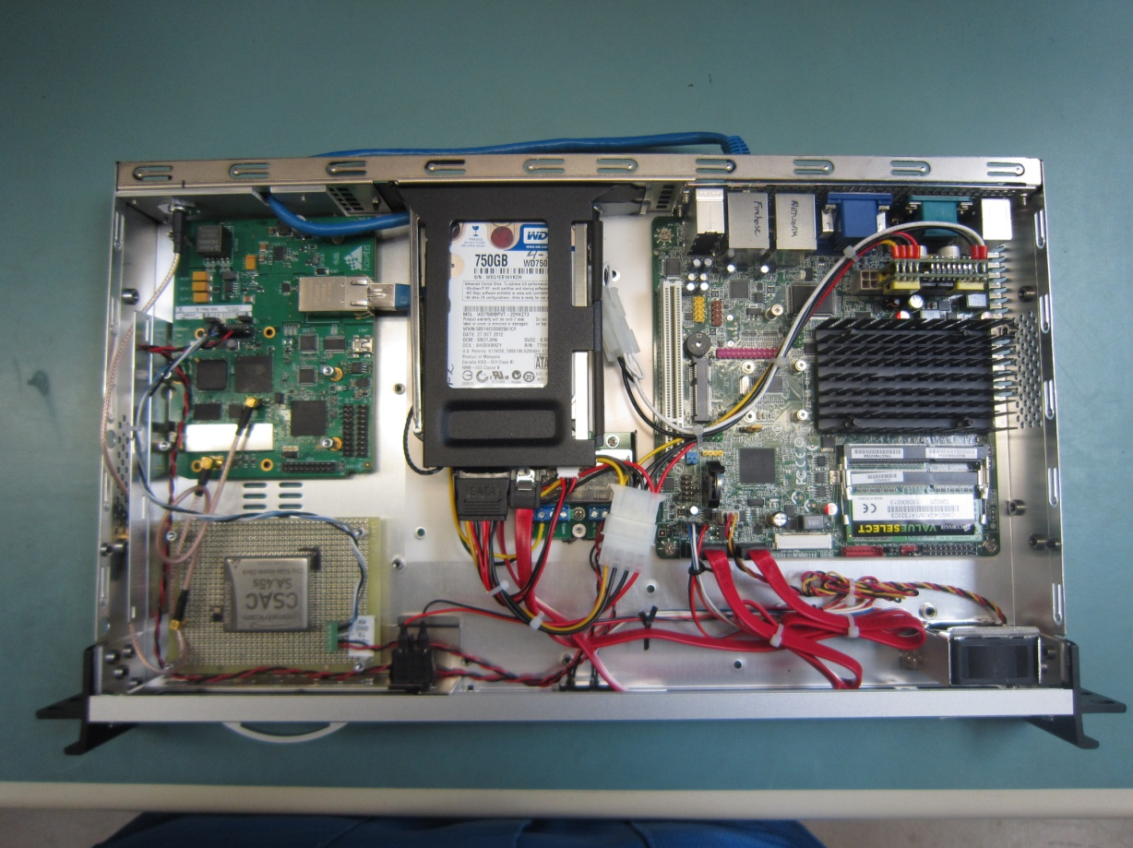

**Hard-drive**

**PC**

**CSAC**

**DGFE**

Figure .2 – FireHose Data Collection System - Interior

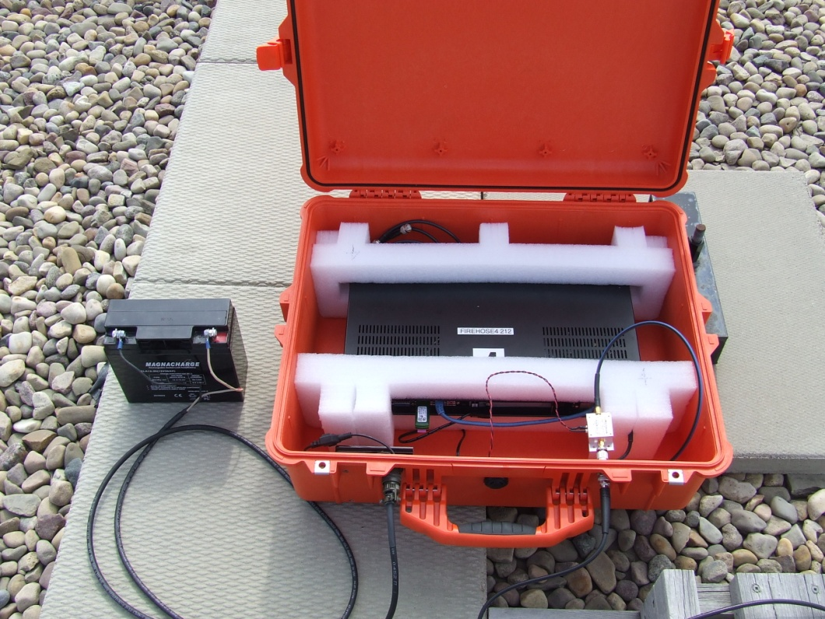

Figure .3 – FireHose Data Collection System

#### Digital GNSS Front End

The Digital GNSS Front End (DGFE or FireHose) is a dual frequency L1/L2 receiver front end designed for software receiver and interference detection systems (D17063, D17088). It can collect L1/L2 data at rates of eiter 2.5 Mega-samples per second (Msps), 5 Msps, 10 Msps and 20 Msps. Data quantization ranges from 1 bit to 8 bits depending on the data rates. The sampling and bit rate are designed around the 100 base-T LAN with the FireHose’s maximum sustained throughput set to 83 Mbits per second. During most of the jammer detection and geo-location tests, the DGFE used 5 Msps and 8 bits of L1 sampling. Both in-phase (I) and quadrature-phase (Q) data are available. The DGFE has a built in NovAtel OEMV-1DF dual frequency L1/L2 GNSS receiver that actively tracks GNSS satellites and provides accurate time to the rest of the receiver. The DGFE data collection hardware and GNSS receiver share the same clock and the GNSS receiver’s 1 pulse-per-second (PPS) is used to synchronize the devices. An external Chip Scale Atomic Clock (CSAC) is used as the receiver’s primary oscillator and helps the system maintain accurate and predictable time during GNSS jamming. All data provided by the DGFE is accurately time tagged using the internal GNSS time solution. In addition to the L1/L2 I and Q data stream, the DGFE provides NovAtel standard binary time tagged range measurement logs that contain GNSS satellite range information including phase and, pseudorange observations plus C/N0 for each tracked signal at a 1 Hz rate. Position, ephemeris, clock offsets, clock-steering and CSAC status are also monitored.

##### OEMV-1DF GPS Receiver

The NovAtel OEMV-1DF GNSS receiver is embedded in the DGFE. It is a high precision dual-frequency GNSS receiver with 36 channels capable of tracking L1 and L2 GPS signals. It features L1 C/A code pseudorange measurements to 4 cm RMS and L2 P(Y) codeless pseudorange measurement to 8 cm. Phase for L1 and L2 has a RMS of 0.5 to 1 mm respectively. The OEMV-1DF tracks the available GNSS satellites and solves for position and time. It generates a 1 PPS pulse that is used for timing the raw I/Q sampling for the DGFE. Output from the OEMV-1DF via the Ethernet interface includes: position, time, clock offsets and range (pseudorange and phase) measurement. The software to steer the CSAC is programmed into the Application Programming Interface (API) section of the OEMV-1DF. For the Petawawa test, the GNSS receiver was running in single point mode, where it estimates both position and time. It is also possible to run the GNSS receiver in fixed position mode provided accurate antenna coordinates are available. In fixed position mode, only time is estimated and fewer than 4 satellites could be used before time estimation (and clock steering) is lost.

### Sprinkler Data Collection System

The Sprinkler data collection system is based around an OEM628 running modified firmware that outputs the RawIQData message (D19080, D19432). The system uses a Symmetricom Chip Scale Atomic Clock (CSAC) (Symmetricom, 2011) steered by the OEM628 (D18058) to maintain accurate and predictable timing during jamming events. A BeagleBone Black (BBB) Linux computer running Angstrom is used with a small touchscreen LCD and custom software for data collection. A removable 16 GB µSD card can store raw data for 10 days. The BBB and OEM628 are interfaced via 100 Mb Ethernet. The entire system is packaged in a waterproof Pelican 1300 case.



Figure .4 – Sprinkler Test Hardware Configuration

|  |  |
| --- | --- |
|  |  |

Figure .5 – Sprinkler Data Collection System

#### OEM628 Sprinkler Receiver

The prototype OEM6 Sprinkler is a standard OEM628 with modified firmware that outputs a 5.2 ms burst (at 12.5 Msps) of raw 1 bit I/Q data at the beginning of each second. This burst is timed to coincide with the receivers 1PPS. Both 1 bit in-phase (I) and quadrature-phase (Q) data are available at a maximum sampling rate of 12.5 million samples per second (Msps). The data can be requested using the standard NovAtel log command and output as a binary (recommended) or an ASCII message. The Sprinkler data frequency and sample rate can be controlled using the new FIREHOSECONTROL command. This allows you to tune to specific bands and frequency offsets. All data provided by the Sprinkler is accurately time tagged using the internal GNSS time solution. In addition to the I and Q data stream, any of the other standard NovAtel logs are available including position, range, ephemeris and satellite status messages.

### Chip-Scale Atomic Clock (CSAC)

Both data collection systems use a 10 MHz Symmetricom SA.45s Chip-Scale Atomic Clock (CSAC) to maintain accurate/predictable time while being jammed. The CSAC replaces the TCXO normally used by the DGFE and Sprinkler. The CSAC is a low-power atomic clock with a 4 x 3.6 x 1.1 cm form factor. It uses 3.3 VDC, draws less than 120 mW and has an operating temperature of -10º C to 70º C. The CSAC is actively steered by the OEMV1DF or OEM628 via an API when the OEM receiver has valid GNSS timing. Steering is automatically disabled when the OEM receiver’s GNSS satellite count falls below 4.

### NovAtel GPS-702-GG Antenna

The NovAtel GPS-702-GG Antenna was used with both the FireHose and Sprinkler data collection systems. The GPS-702-GG is a survey quality L1/L2 GNSS antenna offering combined GPS and GLONASS signal reception and features a PinwheelTM antenna element for low multi-path and a stable and phase centre. A 5 m antenna cable was used on all systems and power was supplied by the receivers to power the antenna’s pre-amp. The GPS-702-GG has a 12 dB gain roll-off from zenith to horizon for L1 and an 11 dB roll-off for L2. The nominal LNA gain is 29 dB.

## Prototype Software

Prototype software includes real-time data collection and display programs as well as post-mission processing programs for data extraction, jammer identification and geo-location.

Code was checked into Perforce source control databases located on the NovAtel network. Each piece of software and firmware are itemized below along with their appropriate compiler.

Table .1- Prototype Software

|  |  |  |  |
| --- | --- | --- | --- |
| **Description** | **File** | **Date** | **Compiler** |
| **FireHose Control Display Software** (CDU)– for real-time data collection and display. C++, .NET, CLR | FireHoseCDU.exe | 19 Sept, 2014 | Microsoft Visual Studio 2010 Professional – this will not port up because VS2012 does not support .NET GUIs |
| **FireHoseFFT** – Post mission processing of FireHose or Sprinkler binary data to generate a FFT Spectrum comma delimited file for plotting. C++ | FireHoseFFT.exe | 13 Feb, 2014 | Microsoft Visual Studio 2012 Professional |
| **FireHoseCheck** – Scan through binary FireHose/Sprinkler files and look for missing packets – also dumps header info. C++ | FireHoseCheck.exe | 16 Sept, 2014 | Microsoft Visual Studio 2012 Professional |
| **FireHoseGPSCheck** – Scan through OEM6 binary files and extract clock offsets, average C/N0, number of Sv’s. Clock offsets are used in FireHoseTDOA | FireHoseGPSCheck.exe | 24 Oct, 2014 |  |
| **FireHoseIdentification** – Scan through binary FireHose/Sprinkler files performing an autocorrelation looking for repeating patterns typical of civilian jammers – will output frequency of repeatable pattern and ratio to noise. C++ | FireHoseIdentification.exe | 30 Sept, 2014 | Microsoft Visual Studio 2012 Professional |
| **FireHoseCorrelator** – computes TDOA between 2-10 stations using FFT Cross Correlation techniques – work with onboard CPU and or Nvidia GPU and CUDA. C++ and CUDA | FireHoseCorrelator.exe | Sept 18, 2014 | Microsoft Visual Studio 2012 Professional, NVIDIA CUDA 5.5, NVIDIA Nsight 3.1 |
| **FireHoseTDOA** – takes the output from FireHoseCorrelator and computes jammer positions from the computed TDOA’s using least squares. C++ | FireHoseTDOA.exe | Sept 18, 2014 | Microsoft Visual Studio 2012 Professional |
| **NeedlesGUI** – C++ code to collect Sprinkler data from an OEM628. To be used with Linux Angstrom onboard a BeagleBone Black – uses an Ethernet socket and GTK+ GUI. Compiles with g++ onboard the BBB | NeedlesGui.exe | Oct, 2014 | g++ onboard BeagleBone Black running Angstrom Linux |
| **GardenHose Firmware** –C++ and FPGA code to collect digital RF data from the FireHose board | Main0726_2013.bin eBurner.bin FPGA1031_110.dat | 26 July, 2014 | Actel SoftConsole for microcontroller, Libero for FPGA – see DSTS D16100 for a description of the code and tools |
| **Sprinkler Firmware** – Special 6.3 version of OEM firmware for use on the OEM628 | OEM060300SN0089.hex | 19Mar, 2014 | Greenhills Multi C++ Compiler and Linker |
| **PulseTracker** – Chirp jammer characterization software used to identify individual jammers – for FireHose only. C# code | PulseTracker.exe | 13 May, 2014 | Microsoft Visual Studio 2012 Professional |
| **CSAC API for OEM628** – API run on the OEM628 to control the Symmetricom Chip Scale Atomic Clock via RS232 – steers the CSAC based the OEM628 clock offset. (D18058) | zM6.hex | 8 Jan, 2014 | Greenhills Multi C++ Compiler and Linker |
| **CSAC API for OEMV1DF** - API run on the OEMV1DF to control the Symmetricom Chip Scale Atomic Clock via RS232 – steers the CSAC based the OEM628 clock offset. (D18058) | CSACSteerAPI.hex | 11 April 2013 | Greenhills Multi C++ Compiler and Linker |

### Perforce Repository

The code for the CDUs, API’s and post-mission analysis software are located in:

Perforcesrv:1636 FireHose

### FireHose Firmware

The FireHose board runs the Gardenhose firmware. This includes **Main0726_2013.bin** run on the SOC Smartfusion’s microcontroller; **FPGA1031_110.data** on the Smartfusions’s FPGA; and the bootburner **eBurner.bin**. This firmware and FPGA image are described in: D16100 and D17063.

### Sprinkler Firmware

The Sprinkler Firmware (**OEM060300SN0089.hex**) is a special OEM628 load based on version 6.3 firmware. The code resides in: ***Perforce//M6/sb/pfenton/FireHose.*** *The special resides in:* ***\\flsrv002\Oem-sensors\Spec_SW\M6\6.300\6300S89.*** The ICD for the special commands and message pertaining to the sprinkler is contained in: D19080 and D19432.

### PC Based Command-Display Utility

The FireHose Command-Display Utility (CDU) software was used for data collection from PCs running Windows 7. The CDU interfaces with both the FireHose DGFE and the OEM628 Sprinkler via Ethernet and configures either receiver for data collection. Besides acting as an interface to control the receivers, the CDU also records all incoming raw I/Q RF data as well as GNSS range, position and clock data. Data is logged to files given a unique name including the systems ID number and the current date and time. The CDU can be setup for automatic startup and logging. A manual explaining the operation of the CDU for the FireHose is located in D17088 and for the Sprinkler in D19432. The AGC based jammer detection algorithms were implemented within this software as well. It kept track of the time, duration and strength of jamming events and informed the user.

### Linux Based Data Collection Utility

The NeedlesGUI data collection program is written in C++ and uses the GTK library for graphics. The GUI was constructed using Glade in an Ubuntu Linux Virtual Box run from Windows 7. It is compiled using g++ onboard the target platform BeagleBone Black running the Angstrom Linux operating system. To simplify compiling, a “bash” file was written and is executed by issuing the following command:

***sh compileNeedles.sh***

compileNeedles.sh contains on one line:

!/bin/bash -eg++ `pkg-config –libs --cflags gtk+-2.0 gthread-2.0` NeedlesGui.cpp NeedlesOptions.cpp -o NeedlesGui

# Jammer Detection with Automatic Gain Control

The automatic gain control (AGC) value available on NovAtel’s receivers is useful for detecting jamming attacks. RF signals comprised of GNSS signals and interference and noise are received by the systems antenna, where they are filtered leaving the GNSS signals, In-Band interference and noise. The RF signals (analog) are then fed into the receiver’s analog section where they are amplified, down-converted and filtered. The filtered analog signal or Intermediate Frequency (IF) signal is then converted to digital data using an analog to digital converter (ADC) and fed into the receiver processing loops for signal acquisition and tracking. In order to keep the analog signal at a nominal value that will maximize the signal over the receiver noise, a variable gain amplifier is placed in front of the ADC. The receiver monitors the digitized data and computes new AGC values which control the amplification (gain) from the VGA.



Figure .1 – Illustration of OEM6 AGC Control Loop

In the OEM6, the AGC value is a pulse width ranging from 0 to 8000 that is fed into the Variable Gain Amplifier (VGA) and is used to adjust the attenuation level of each RF section. A value of zero has no amplification and 8000 has maximum amplification. Typical values are in the range of 4000 to 6000. The AGC responds to the power of the input data digitized by the RF path’s Analog to Digital Converter (ADC). When a jammer comes in range or is switched on, the RF power increases and the receiver will adjust the AGC (by decreasing its value) and hence the gain on the VGA to keep the RF power in range.

In order to monitor the RF signal, the receiver uses the digital data from the ADC. The digital data is fed into a Probability Distribution Function, which counts the occurrence of bit values from the incoming data, these are call bins. Looking at the bin counts will gauge whether the input data is Gaussian (normally distributed) in nature. A Gaussian (normal) plot will have 0.5 of the power in the middle two bit (bins). If all of the power is in the middle bits (-0, +0), then the RF signal is weak and the AGC will be increased. If all of the power in in the outside (high +/-) bits, then the RF signal is too strong, the RF path is probably saturated and the AGC should be decreased.

Table .1- ADC Bits to PDF Bin Mapping (from D11471)

|  |  |  |  |
| --- | --- | --- | --- |
| **3 bits selected from ADC** | | **Mapped PDF bin** | |
| **Decimal** | **Binary** | **Binary** | **Bin number** |
| -3 | 111 | 000 | 1 |
| -2 | 110 | 001 | 1 |
| -1 | 101 | 010 | 2 |
| **-0** | **100** | **011** | **3** |
| **+0** | **000** | **100** | **4** |
| +1 | 001 | 101 | 5 |
| +2 | 010 | 110 | 6 |
| +3 | 011 | 111 | 6 |

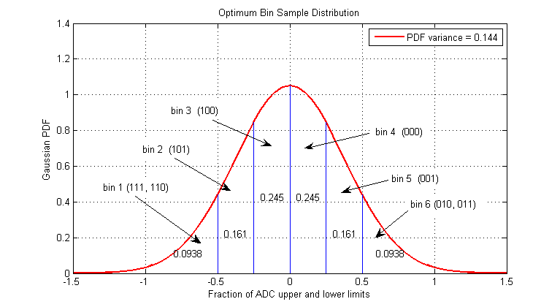

Figure .2 – Illustration of PDF Distribution over 6 bins (from D11471)

By monitoring the AGC in real-time and looking for dips in AGC values, it is fairly straightforward to detect a jammer. The first thing to remember is that the GNSS signals tracked by the receiver are buried in the noise. So the noise is typically the dominate signal we are monitoring when setting the receiver’s AGC. Satellites rising and falling or being blocked have very little effect on the RF signal, the PDF and hence the AGC. This is illustrated by the following plot of L1 AGC captured overnight on NovAtel’s rooftop.

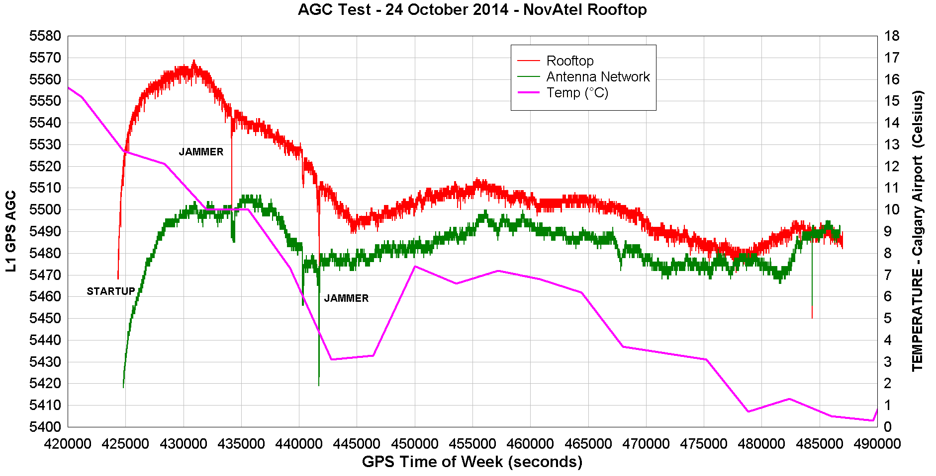

Figure .3 – OEM628 L1 AGC from NovAtel Rooftop – 23-24 September 2014

Three curves are plotted on this graph. The first is the AGC (Red) from an OEM628 and 702 antenna setup on roof of NovAtel’s office in Calgary. Both the receiver and antenna are outside. The second curve (Green) is from an OEM628 connected to a NovAtel model 750 3D Choke-ring antenna via NovAtel’s antenna network. The OEM628 is inside an office and the 750 antenna is on NovAtel’s rooftop approximately 10 m NW of the rooftop OEM628 (Red). The third curve shows the outside temperature as recorded 2 km east of NovAtel’s building at the Calgary International Airport.

Examining the three curves there are several interesting features. The first is that the AGC ramps up by 80 to 100 during the startup of both OEM628 receivers. As the receivers (located in a Sprinkler box) warm up the AGC increases. After the receiver temperatures stabilize, the AGC sees long-term variations as the outside temperature effects the antennas. Also interesting are the two rapid dips in the AGC values near the middle of the test. These probably correspond with jammers driving past NovAtel’s building – mostly likely on Deerfoot Trail. The third dip at the end of the test was only 1 second in duration, but seen on both receivers. The cause of this is unknown and could be due to a common process within the receivers or a sudden RF burst in the area, possible from NovAtel or the Airport.

Besides noise, the dominant long term movement is caused by temperature variations on the antenna’s LNA and the receiver’s frontend circuitry (filters, amplifiers). As the amplifiers in the antenna and receiver heat up they become less efficient and the AGC is increased to compensate. As the amplifiers cool, they become more efficient and the AGC is decreased to compensate.

So, regardless of the long term movements of both receiver’s AGC values, the effect jammers are relatively easy to see in the data. Could the AGC values on a moving vehicle be used to detect a jammer? First it is necessary to examine the data from a receiver as is moves across a typical urban environment to see if major drops occur as signals are block by buildings and objects seen in urban landscapes.

The following graph shows an OEM628’s L1 AGC captured from a vehicle as it drove from Calgary’s NorthHill Mall to the NovAtel building (20 minute trip). This is a similar hardware configuration to that used on NovAtel’s rooftop during the test shown in Figure 4.3.

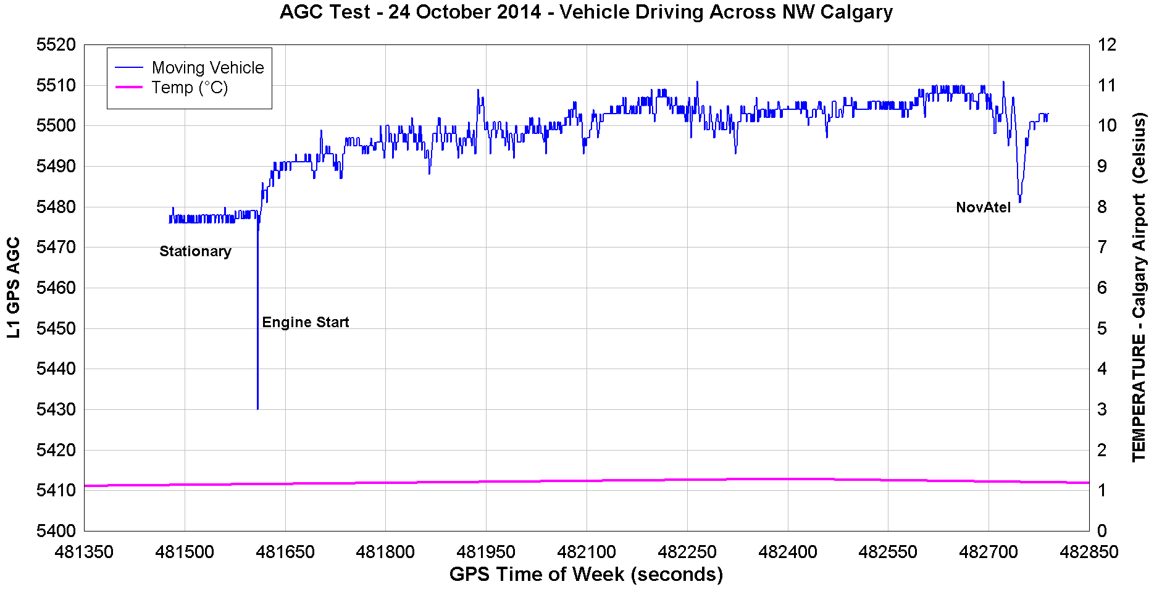

Figure .4 – OEM628 L1 AGC from Moving Vehicle - 24 September 2014

During the dynamic test, the receiver had already been running prior to the data shown in Figure 4.4, so we don’t see a rapid ramp up similar to that seen during the rooftop test. There is a 1 sec rapid drop in the AGC when the vehicle was started. Other than that, the AGC does not have any major drops as the vehicle drives across Calgary. When the vehicle reaches NovAtel, there is another drop of about 20 which may be due to a RF hotspot at NovAtel.

Another AGC data set from the same vehicle and receiver was captured 5 hours later in the area around NovAtel’s building. During this test, the receiver has been off for 5 hours previous and so we see a similar AGC ramp up (due to receiver warmup) to that seen on the rooftop receivers the previous afternoon. The ramp up is similar in magnitude and duration. The L1 AGC plot itself has no major drops except for three areas: an area in the NovAtel parking lot at the start and end of the test and a brief AGC dip in the middle of the test while the vehicle drove north on Deerfoot Trail past the Atrium building.

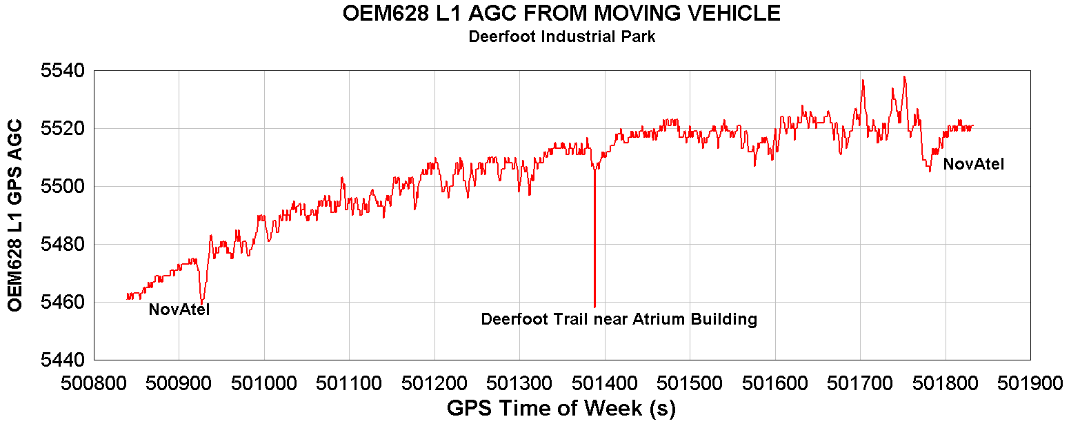

Figure .5 – OEM628 L1 AGC from Moving Vehicle - 24 September 2014

To use the AGC to detect RF interference and jammers, it is necessary to establish thresholds that the AGC must drop over a period of time before it triggers a jamming event. If we use 300 seconds for a typical period, what are the typical standard deviations for stationary and dynamic receivers and what would be an acceptable level for the AGC to drop before triggering a jamming event? Thompson et al (2011) uses 6-σ and the thresholds obtained using this are very similar to those found by NovAtel during experimental testing with live jammers (D18494, D19779).

Looking at the AGC statistics over 300 s for each of the data sets shows that a dynamic receiver has a standard deviation about 4 times that of a stationary receiver. Multiplying the standard deviations by 6 gives a 6-σ figure of about 8.4 for a stationary receiver and 28.2 for a dynamic receiver.

Table .2- OEM628 L1 ADC Statistics for Stationary and Dynamic Receivers (300s)

|  |  |  |  |
| --- | --- | --- | --- |
| **Dataset** | **Maximum - Minimum** | **Standard Deviation** | **6-σ** |
| **Stationary Rooftop** | 6 | 1.1 | 6.6 |
| **Stationary Antenna Network** | 8 | 1.4 | 8.4 |
| **Dynamic 24Oct14 AM** | 22 | 3.8 | 22.8 |
| **Dynamic 24Oct14 PM** | 31 | 4.7 | 28.2 |

Thompson et al (2011) discusses compensating the AGC for temperature effects. They measured the AGC values over a range of temperatures and derived a linear fit to adjust the AGC. For their research this proved useful, since they were able to reduce their threshold 6-σ values down to about +/- 25 from a long term average (days). For the current system we would have to derive two compensation equations; the antenna temperature compensation and the receiver temperature compensation along with their relationship. Also in our case, a temperature compensation of the antenna would be difficult since we currently don’t have an antenna temperature available. Thompson et al (2011) are also using a long term average and thresholds around that to detect jammers. Our research took a more sophisticated approach where we use the instantaneous AGC’s departure from a filtered AGC as the test.

The following equation was used to filter the AGC:

|  |  |
| --- | --- |
|  | Eq . |

where:

is the filtered AGC at the current time t,

${FilteredAGC}_{t-1}$ is the previously filtered AGC at time t-1,

${AGC}_{t}$ is the instantaneous AGC at the current time t, and

$∝$ is filtering coefficient, typically 0.001.

We also used a “steady” AGC threshold to ensure that outliers and jammers did not contribute to the filtered AGC. This outlier was set at 10 for the Sprinkler receiver system. We used the movement states of “rising”, “falling” and “steady” to judge if the instantaneous AGC was stable enough to contribute to the filtered value. If the instantaneous AGC was higher than the previous epoch’s instantaneous AGC by more than 10, it is declared to be “rising”. If the instantaneous AGC was lower than the previous epoch’s instantaneous AGC by more than 10, it is declared to be “falling”. If it wasn’t “rising” or “falling” it was declared to be “steady” and used to compute a new filtered value. In addition, once a jammer was detected by having the AGC fall below the jamming threshold, a jamming flag was set that would not be cleared until the AGC recovered to within 2 of the Filtered AGC when the jamming started. Once the jamming flag was set, the instantaneous AGC would not be added to the filtered values, maintaining a “First Falling” AGC value.

The following two graphs demonstrate how this method of jamming detection works using the data set collected at NovAtel on October 24, 2014. A threshold of 30 was chosen by rounding up the most conservative value found in Table 4.2. The first graph is using the Sprinkler system with a “Network” antenna feed. The dark green line shows the instantaneous AGC, while the bright green line shows the filtered AGC. The instantaneous AGC drops quickly below the filtered value at GPS time of week (TOW) 441726 s. A jamming event is declared at 44127 s and the jammer has move past detectable range at about TOW 441762 s.

The second graph is using a Sprinkler system with a 702GG antenna running on NovAtel’s rooftop. This antenna was near NovAtel’s observation dome and about 10 m further from the edge of the building than the network antenna. The pink line on the graph is the filtered value, while the red line shows the instantaneous AGC values. The jammer is evident as the instantaneous AGC falls consistently below the filtered AGC value at 441719 s, but it does not fall below the detection threshold until 441753. The jamming event ends at about 441765 s.

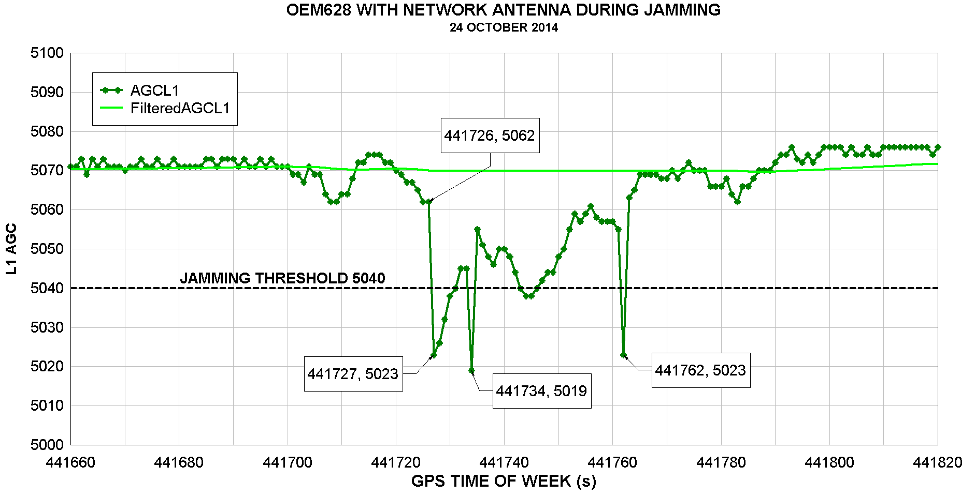

Figure .6 – Using AGC and 6-σ to Detect Jammers – “Antenna Network” Receiver

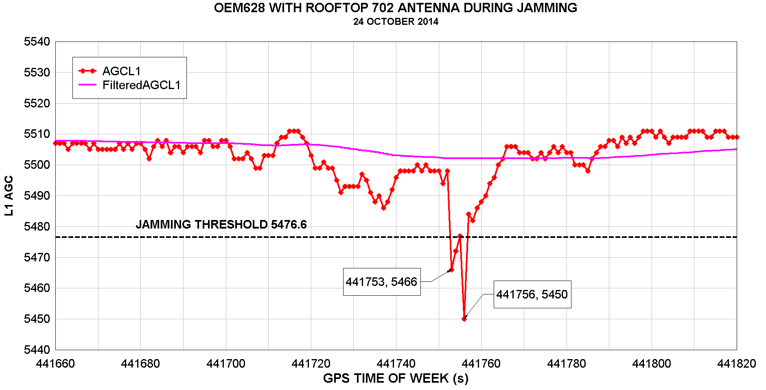

Figure .7 – Using AGC and 6-σ to Detect Jammers – “Rooftop” Receiver

The detection threshold of 30 used here is probably conservation and a value closer to 20 would have been faster to detect the jammer. A threshold of 30 has been used for several months at NovAtel with success, but a lower value warrants further examination.

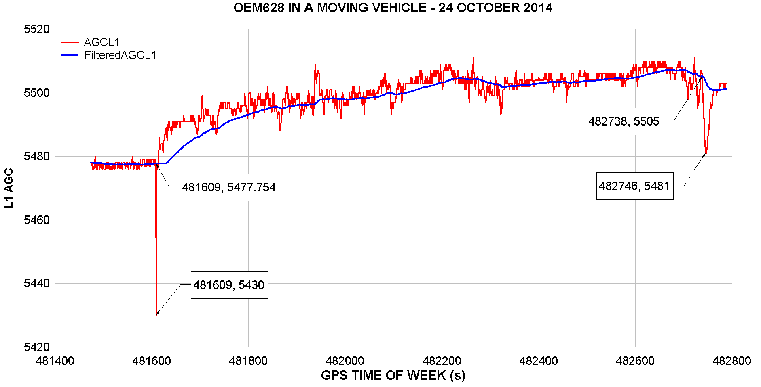

Figure .8 – Using AGC and 6-σ to Detect Jammers – Mobile Receiver

Figure 4.8 shows the filtered and instantaneous AGC for the mobile receiver on the morning of 24 October 2014. Using the difference between the filtered and instantaneous value as a measure of jamming, the event near the start of the test (482609s) would have been marked as jamming. This may have happened when the vehicle was started. Interesting enough, if the threshold was reduced down to 20, the drop in AGC at 482746 s while the vehicle was in the NovAtel parking lot would also have been marked as jamming. Examining of the lag in the filtered value from the instantaneous value indicates that for dynamic applications a larger filtering coefficient should probably be used.

# JAMMER IDENTIFICATION

Civilian jammers also known as personal privacy devices (PPD) are commonly being used to jam GNSS signals. Using AGC detection methods mentioned earlier in this paper, NovAtel’s Calgary office normally sees the effect of 1 to 2 civilian jammers per day. All of the jammers discussed in literature appear to be mass produced devices and sold over the internet. In addition to the detection and geo-location of jammers, it is also desirable to identify the various jammers. Two methods of jammer identification have been discussed in literature; the first is based on physical characteristics, and; the second on its signal characteristics. Signal characteristics are the most useful for tracking jammers, first because we rarely can visually inspect the actual jammer and second because the signal characteristics can be used to track the jammer.

Most of the jammer geo-location research (signal correlations) we have done at NovAtel during 2013-2014 will work for one jammer at a time. To geo-locate multiple jammers at a time it will be necessary to acquire and track individual signals. To track these jamming signals a parameterization of the signal is necessary or correlation against a library of recorded signals is required. We can discount the method of correlation against a library of signals, since the quality of jammers is poor and it is likely that there are large unit to unit variations and or variations between the same units each day.

Mitch et al. (2013) has suggested one method of parameterization which allows them to track jammers. Mitch Ryan has gone on to write his PhD thesis on this topic which is unfortunately locked until 2019. Pat Fenton has also developed a tracking method for the 8 bit data from the FireHose and this is discussed in the section on the “PulseTracker” software. From either of the methods, we could obtain the signal phase and used this for Time of Arrival observations in Geo-location. Both methods have their advantages and a 6 month research project would be required to fully develop these methods for real-time jammer tracking.

## Characteristics of Civilian Jammers

Mitch et al. (2013, 2011) and Guinand et al. (2012) provide in-depth analysis of civilian jammers and offer several methods of classifying them based on their physical and signal characteristics.

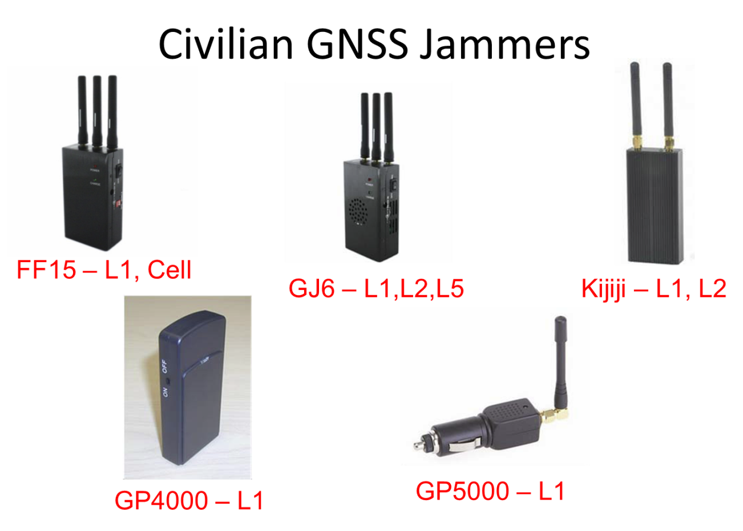

Figure .1 – Civilian Jammers used during Petawawa 2013 Tests

Common civilian jammers tested at Petawawa in 2013 are shown in Figure 5.1. Classification based on physical characteristics is given in Mitch et al. (2011), which classifies jammers based on battery power and antenna characteristics. There are three categories: Group 1 jammer is designed to plug into a cigarette lighter or typical power port in a vehicle; Group 2 jammer has an internal rechargeable battery and an external antenna; Group 3 jammer has an internal rechargeable battery and an internal antenna. Table 5.1 gives the physical categories for the jammers shown in Figure 5.1. Signal characteristic as determined by Guinand et al. (2012) are also provided in this same table.

Table .1 – Jammers Used During NAV CANADA – CFB Petawawa Tests 2013

|  |  |  |  |  |  |  |  |
| --- | --- | --- | --- | --- | --- | --- | --- |
| **Jammer #** | **Model Name** | **Max.**  **Power**  **(dBm)** | **Group1** | **L1 Sweep Rate2 (Hz/s)** | **L1 Period2 (s)** | **Chirp Repetition Rate2 (kHz)** | **Description** |
| 1 | FF15 | 10 | 2 | 1.96x1012 | 9.70x10-5 | 104 | 3G/L1/GSM Jammer |
| 2 | GJ6 | 10 | 2 | 1.57x1012 | 1.37x10-5 | 72.9 | L1/L2/L5 |
| 3 | L1/L2 | 10 | 2 | NA | NA | NA | L1/L2 |
| 4 | GP4000 | 10 | 3 | 2.6x1012 | 9.15x10-6 | 109 | L1 |
| 5 | GP5000 | 10 | 1 | 6.05x1011 | 3.96x10-5 | 25.2 | L1 |

1. Mitch et al. (2011)
2. Guinand et al. (2012) (CRC)



1. Figure . – Key Characteristics of a Chirp Jammer

In later research Mitch et al. (2013) investigates a method of acquiring and tracking chirp jammers based on signal characteristics given below and shown in Figure 5.2. These signal characteristics include:

f starting frequency of the chirp in Hz,

T chirp length in seconds, with T = Tu + Td

tu ramp up start time in seconds, with Tu = td - tu

td ramp down start time in seconds,

αu upward frequency rate of change in Hz/s, and

αd downward frequency rate of change in Hz/s.

The time period of the ramp up and the ramp down are Tu and Td respectively. The ramp up start time and ramp down start times could be used as time of arrival observations for geo-location and differencing them between stations would give Time Differences of Arrival (TDOA), which are used later on in this document for jammer geolocation.

Mitch et al. (2013) provides a thorough method of acquiring and tracking chirp signals using either time domain measurements or the output of a Fast Fourier Transform (FFT). The FFT uses short accumulation lengths to prevent power loss due to the changing frequency of the incoming signal. Visually this is demonstrated by the following two graphs. In Figure 5.3 and Figure 5.4 the horizontal axis is time and the vertical axis is frequency centered on L1 (1575.42 MHz). These graphs consist of vertical slices which are FFT’s with 16 bins. A sliding window of 16 samples (12.8 µs at a sample frequency of 12.5 Msps) is run through the FFT and the window moves one sample each time a new FFT is computed. The vertical axis is colour coded with bright green as maximum power and blue as minimum power. The trace shown in bright green shows the change in the frequency of peak power for the civilian jammers tracked at NovAtel. These can be used to extract the signal characteristics.

|  |  |
| --- | --- |
|  |  |

Figure .3 – Peak Frequency Plot of Civilian Jammer Observed 31 January 2014

|  |  |
| --- | --- |
|  |  |

Figure .4 – Peak Frequency Plot of Civilian Jammer Observed 24 September 2014

Table .2 – Characteristics of Civilian Jammers Observed at NovAtel

|  |  |  |  |  |  |  |  |
| --- | --- | --- | --- | --- | --- | --- | --- |
| Signal | Period T  (us) | Chirp Rate  1/T (KHz) | Ramp Up Period Tu  (us) | Ramp Down Period Td  (us) | αu  (KHz/us) | αd  (KHz/us) | Start Frequency (kHz) |
| Jan 31, 2014 | 8.85 | 113.994 | 5.51 | 3.34 | 2,269 | 3,742.5 | 1,569,170 |
| Sept 24, 2014 | 17.9 | 55.865 | 8.73 | 9.17 | 1,174 | 1,118 | 1,568,920 |

### Measuring Chirp Rate

One of the key identifying signal characteristics of a civilian jammer is its chirp rate, which is the rate at which the chirp pulse is repeated. In Figure 5.3 the chirp is repeated approximately every 8.9 µs giving the January jammer a chirp rate of approximately 114 kHz and in Figure 5.4 the chirp is repeated approximately every 17.9 µs, giving the September jammer a chirp rate of 55.9 kHz.

A relatively straight forward method of measuring chirp rate is to use an autocorrelation. The data for the autocorrelation comes from the digital receiver, in this case an OEM628 with Sprinkler software. It is important that the clock of the digital receiver has the correct frequency or the chirp rate will be incorrect. We expect the chirp rate to drift though and change from day to day, since the civilian jammers probably use low cost oscillators and that along with temperature variation probably have a fairly large effect on the signal from the jammer.

The amount of data (number of samples) to be used in the autocorrelation depends on several factors: the chirp rate of civilian jammers and the sampling rate of the receiver. We need a unique portion of each chirp to perform the autocorrelation. A full chirp would be ideal, but ½ to 1/3 would be sufficient since neither is repeated within the chirp itself.

In the case of the OEM628 Sprinkler the sampling rate is 12.5 Msps. The studies by Mitch et al. (2011) tested civilian jammers with chirp rates from 37.1 kHz to 125 kHz. Guinand et al (2012) tested civilian jammers with chirp rates from 71.2 kHz to 107.5 kHz. Taking a low chirp rate of 37.1 KHz and sampling at 12.5 Msps gives us a chirp length of 337 samples. Taking a high chirp rate of 125 kHz and sampling at 12.5 Msps gives us a chirp length of 100 samples. So for the autocorrelation, a sample length of 100 samples would allow us to correlate the entire chirp of a fast rate jammer and about 1/3 of a low rate jammer. If we take too short of a portion of a chirp there is a good chance we will arrive at a chirp rate higher that actual.

The next question is: what is the best portion of data to use during the chirp rate computation? That would be the portion with the strongest jammer signal which is easily determined from the AGC. Take the portion where the AGC is lowest during the jamming event.

If we do the autocorrelation over a sufficiently long data set (1 to 2 seconds) we can then do a FFT of the autocorrelation peaks to determine the chirp rate. In some cases the harmonic of the rate might be highest, so it is important to look for lower harmonics for the correct chirp rate. This is illustrated for the September 24, 2014 data which we previously measured (using the Peak Frequency vs Time Graph) at a chirp rate of 55.9 kHz.

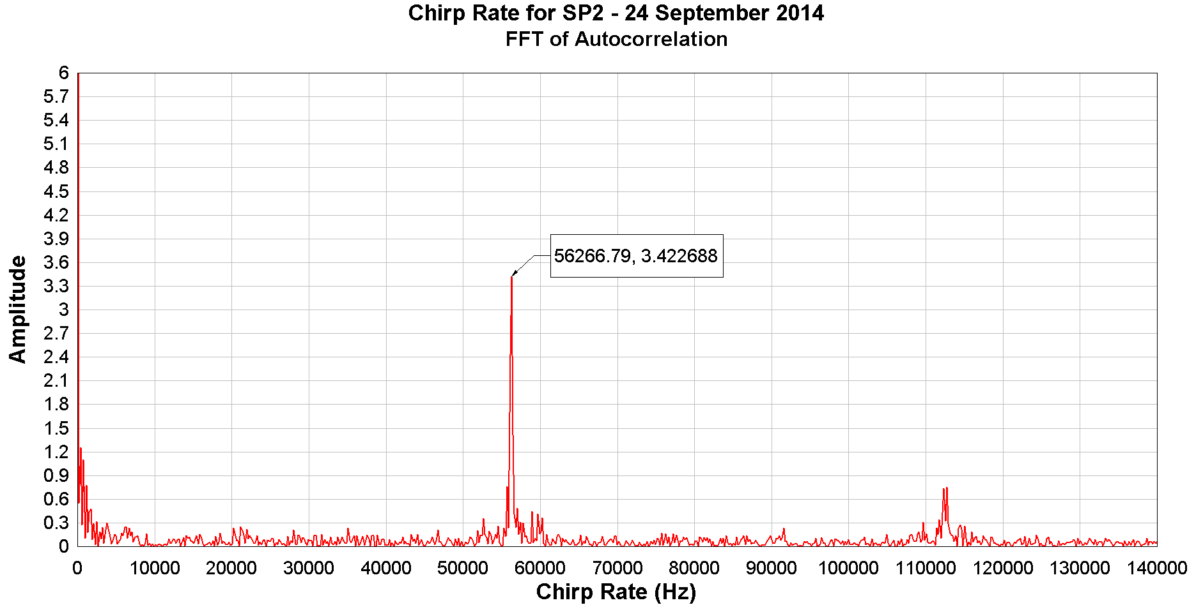

Figure .5 – Chirp Rate for Jammer Observed 24 September 2014 (TOW=347390s)

## Determining Chirp Characteristics – PulseTracker Software

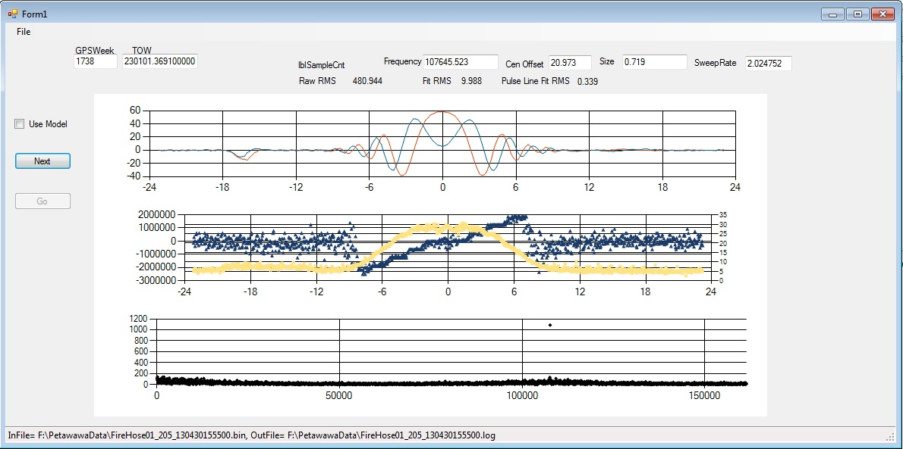

Figure .6 – Civilian Jammer Pulse Detection

The Pat Fenton’s efforts in jammer identification took a different approach from that shown in Mitch et al 2013.

Civilian jammers are identified in NovAtel’s research using the following parameters:

1. Pulse repetition frequency (Hz) – by performing an autocorrelation and extracting the rate from the FFT
2. Center Offset (samples) - first pulse within the data set (in samples) which is the distance of first pulse peak in time domain from start of file. This can then be used to determine the time of the first pulse and subsequent pulses for time difference computations (to 0 on the top graph)
3. 3 dB Size (µs) – size of pulse envelope to the 3dB spot (see top graph)
4. Sweep Rate (MHz/s) – slope of the peak frequency plot (blue line, middle graph)

The PulseTracker software was written Visual Studio Pro 2012 in C# to test this civilian jammer identification method using 8 bit FireHose data from Petawawa. The following algorithm was used to extract the RF signature of a civilian jamming device that produces a swept sign wave type RF signal.

1. **“Detect_Pulse” Function:**

“Detect_Pulse” is used to analyze a buffer of data when we have no idea what to look for in the data. It uses the first ***iWindow*** of samples from the start of the buffer as the reference. If ***iWindow*** contains no pulses, then this function doesn't work and it will continue to search. The ***iWindow*** size is somewhat arbitrary.  It needs to be long enough to capture one pulse.  However, if it is too long, and many pulses are captured, then the result has too many harmonics to sort through. If it is too short, then it may not capture a pulse and there will be no correlations found. Pat Fenton found with the Petawawa data (5 Msps), that a window size of 100 samples (20 us) seemed to work fine.  Where to extract the ***iWindow*** sample set is completely arbitrary.  Pat chose to use the first ***iWindow*** number of samples from the start of the buffer. This algorithm correlates the ***iWindow*** data onto the entire data set using:

Step a: iFFT( FFT(***iWindow***) x FFT(DataSet) )

Step b: compute power at each offset

Step c: FFT(Power)

Step d: Look for frequency content (***dPulseFrequency***) (repetition rate of pulse contained in ***iWindow***)

1. **“FindPulseShapeRef” Function:**

Step a: Find the first pulse within the data set by stacking all the power values into a histogram according to the frequency extracted in part 1 “Detect_Pulse”.

Step b: Determine the size of the pulse by examining the histogram produced in 2a above (Yellow curve in middle chart) for the -3dB points on either side of the max point.

Step c: Determine the rough frequency characteristics by producing a stacked histogram of the frequency at each point across the pulse (blue curve, middle chart)

Step d: Refine the frequency and initial offset by using a least squares linear fit on the detected pulses.

The basic idea of how “FindPulseShape” works is:

* + it uses the provided ***dPulseFrequency*** from Pulse Tracker (1) to establish the expected period window in which to find the pulse.
  + applies a very small FFT (8 points) to compute and stack up common frequencies between period windows.
  + examine the frequency stack-up to extract:
    - center of pulse (in samples)
    - size of pulse (3 dB points) in samples
    - frequency sweep rate in MHz/us

1. **“FitShape” Function:**

Step a: Stack the I & Q data of each pulse, adjusting each pulse for offset, magnitude and phase rotation.

Step b: Fit the I &Q data with a pulse by computing the following parameters:

* Envelope Size
* Sweep Rate

Step c: Plot the stacked IQ data of the average pulse in the top graph.

Step d: Final RF characterization is represented by the following parameters:

* Frequency of pulse – dPulseFrequency (Hz)
* Center Offset (first pulse within the data set (in samples))
* 3 dB Envelope Size (µs)
* Sweep Rate (MHz/s)
* RMS Fit

# Geolocation of Civilian Jammers

Described below are the algorithms used for jammer geolocation using Time Difference of Arrival (TDOA) measurements. The ITU-R (2011) document provides the pros and cons of using TDOA versus Angle of Arrival (AOA) for jammer geolocation. These have been summarized below.

TDOA Strengths

* Simpler antenna requirement than AOA systems. We used a standard NovAtel 702 GNSS antenna
* Site and calibration requirements are simple. For the TDOA, three monitor sites are required and situated to surround the jammer if it is moving. If the jammer is stationary, then geolocation can be done with one stationary monitor and one moving monitor. The antenna direction does not matter.
* TDOA methods work well with wideband, low signal-to-noise (SNR) signals or short duration. A valid correlation can be obtained with less than 1 ms of data.
* TDOA receivers are less complex than AOA antenna arrays and multi-channel receivers.
* The correlation process used to form the TDOA can suppress noise and interfering signals that are uncorrelated between monitoring sites.
* TDOA is less sensitive to multipath with sufficient bandwidth and advanced signal processing.

TDOA Weaknesses:

* TDOA methods are not suitable for use with Narrowband signals such as unmodulated (CW) carriers unless ambiguity resolution methods are used.
* At least two TDOA monitors (one stationary, one moving) re required for a stationary jammer and at least three TDOA monitors are required for a moving jammer. Only one AOA station is necessary for a stationary jammer and two for a moving jammer.
* TDOA methods are sensitive to sources of decorrelation between monitors, including frequency offsets and Doppler effects. Using a receiver such as the FireHose or Sprinkler that steers it TCXO mitigates the frequency offset effects.
* TDOA methods are sensitive to timing errors between monitors. Again this is mitigated in the FireHose and Sprinkler because both these receivers steer their TCXO’s as well as estimate the clock offset using the integral NovAtel GNSS receivers. During periods where the GNSS signals are jammed at the monitors the use of a high-quality clock with a linear and predicable drift pattern such as the CSAC is necessary.
* TDOA methods relying on correlation are not well suited to multiple jammers.
* Signals containing periodic elements such as synchronization pulses may cause problems with determining the correct TDOA correlation.
* TDOA methods are not accurate when the jammer is outside the monitor station network.

The steps for computing a TDOA from RF data collected at multiple sites are given below in Figure 6.1.

AGC readings are another observation that may be suitable for positioning of jammers. AGC’s can be treated as a scaled range observation where the scale factor is a common unknown amongst the AGC readings. It is an inaccurate measurement and only suitable for cases where one jammer is present. It may be suitable for generating approximate jammer coordinates prior to the least squares or as an auxiliary observation along with TDOA observations within the jammer geolocation least squares.

This chapter begins with a discussion of datums, ellipsoids and the Universal Transverse Mapping (UTM) plane. A datum, ellipsoid and mapping plane are used so that the coordinates determined during geolocation can easily be used with existing mapping and positioning systems. A local datum could just as easily be used. A description of the Time Difference of Arrival (TDOA) measurements is given. The TDOA measurements to the jammer are usually measured on the surface of the earth or in the air above. Methods will be presented to reduce these measurements first to a reference ellipsoid and then to the UTM mapping plane so that geolocation computations (discussed in section 7) can be done in an established rectangular coordinate system. While it is certainly possible to use a local coordinate system for geolocation, the GNSS receivers built into the system monitors make it unnecessary, since we have a convenient method of determining monitor station coordinates in an established and accepted coordinate system (UTM).



Figure .1 – Flowchart of Geolocation with TDOA Measurements

## Datum and Ellipsoid

Positioning and geolocation are based on a geodetic datum which is an abstract coordinate system with a set of reference points that help define its relationship with the physical world. The WGS84 datum used with GPS is used herein during the geolocation. With an ellipsoid that is a mean fit for the Earth’s sea-level and the main datum for most GNSS receivers it is an ideal datum to adopt. Observations are reduced down to the WGS84 ellipsoid and also the Universal Transverse Mercator (UTM) mapping plane to allow for rigorous computation of the jammers coordinates on a datum easily used in GNSS devices and displayed on available maps.

We don’t use the Earth Fixed Cartesian coordinate system (X,Y,Z) for jammer geolocation because we typically ignore the elevation because the geometry of the monitoring stations and the TDOA lines of position make it difficult to estimate the elevation (height) of the jammer. If it was possible to get a good vertical separation (100 to 500 m) between monitors such as having one monitor in a plane or helicopter, then height estimation would be viable and the XYZ Cartesian coordinate frame would certainly be useful here.



●

z

E

x

E

y

E

Mean Spin Axis

Mean Meridian of Greenwich

Point on Ellipsoid

Towards North Celestial Pole

Figure .2 – Reference Ellipsoid

The WGS84 datum has the WGS84 ellipsoid associated with it. The semi-major axis and semi-minor axis of the ellipsoid are:

|  |  |
| --- | --- |
|  | Eq . |
|  | Eq . |

A position on the ellipsoid of the WGS84 datum can be represented by a set of curvilinear coordinates referred to as the geodetic coordinates. The geodetic latitude (φ) is the right handed angle between the plane perpendicular to the z axis of the Earth-fixed system and the ellipsoid normal measured along a meridian. The geodetic longitude (λ) is the right handed angle from the Greenwich (zero) meridian to the meridian passing through point P, measured in the plane perpendicular to the z axis of the Earth-fixed system. The height (h) of point P is measured along the ellipsoid normal, and is the distance from the ellipsoid to the point.

The meridian radius of curvature (M) at point P is computed from:

|  |  |
| --- | --- |
|  | Eq . |

The prime vertical radius of curvature (N) at point P is computed from:

|  |  |
| --- | --- |
|  | Eq . |

and e is the eccentricity of the ellipsoid and is computed from

|  |  |
| --- | --- |
|  | Eq . |

In most cases, measurements are made at elevations well above the surface of the ellipsoid. For geolocation it is necessary to reduce these measurements from the terrain level to the ellipsoid surface.

### Reduction of Measurements to the Ellipsoid

The Earth’s surface is approximated by an ellipsoid, which closely fits the mean sea level. This provides us with a mathematical shape from which mapping planes can be developed. The first step of reducing measurements from the local terrain to the mapping plane is to first reduce them to the ellipsoid. Figure 6.3 shows a range measured above mean sea level, with the start at an elevation of h1 and the end at an elevation of h2. The further the stations are from the surface of the ellipsoid (higher elevation), the greater the effect of convergence on the distances.

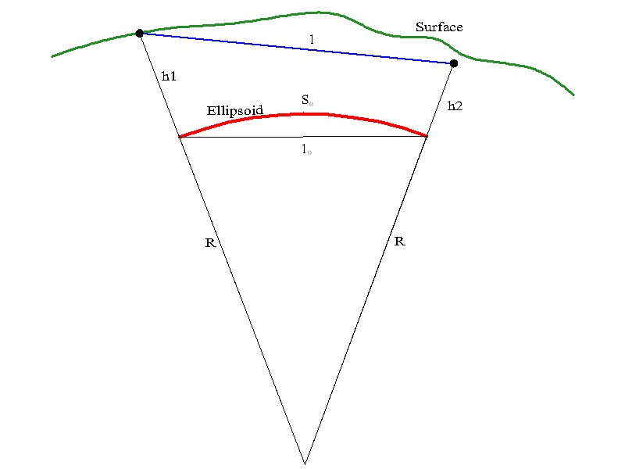

Figure .3- Reduction of Ranges

A range l, measured on the Earth’s surface can be reduced to the ellipsoid (lE=s0) by (Heiskanen & Moritz 1979):

|  |  |
| --- | --- |
| . | Eq 6.6 |

 and  are the deflection between the local horizon and a line parallel to the ellipsoid caused by local gravity anomalies which for our purposes we ignore. ,  and  are the height of station 1, 2 along with the mean height. R is the mean ellipsoid radius along the line, and is computed by:

|  |  |
| --- | --- |
| . | Eq 6.7 |

where M and N are from Eq 6.3 and Eq 6.4 using the mean latitude for  and Az is the azimuth from point 1 to 2.

For a range of 1000 metres and an average elevation of 3000 metres, and ignoring deflections due to gravity, the ellipsoid distance is 47 cm shorter than the terrain distance. At 1000 metres elevation (Calgary), a range of 1000 metres is 16 cm shorter on the ellipsoid than on the surface. As the elevation approaches sea level, the difference diminishes to zero.

The correction of an azimuth from the Earth’s surface to the ellipsoid is negligible.

## Universal Transverse Mercator Mapping Plane

The mapping plane is a mathematical construct whose purpose is to map features on the curved surface of the Earth to a plane. It is not possible to develop the Earth’s surface exactly onto a plane, such that all relationships between features (scale, orientation) are exactly reproduced. Most mapping projections are an attempt to minimize distortions and preserve at least one of the relationships between features. The Universal Transverse Mercator (UTM) projection is a projection on a cylinder tangent to the Earth along a central meridian. UTM divides the Earth into zones of 6º of longitude, with the first zone between 180ºW and 174ºW and the zone numbering proceeding east from zone 1. Western Alberta is covered by zone 11, from 120ºW to 114ºW, with a central meridian of 117ºW. The eastern side of Alberta is covered by zone 12, from 114ºW to 108ºW, with a central meridian of 111ºW. In Calgary, the west side is in zone 11 and the east side is in zone 12.

The UTM projection cylinder cuts the ellipsoid along two standard lines, parallel to the central meridian and equally spaced on either side. A distance on these two meridians would equal a distance on the ellipsoid. A UTM distance between these two meridians would be less than the ellipsoid distance, while UTM distances outside the two meridians would be greater than the ellipsoid distance.

The Universal Transverse Mercator mapping plane was used for rectangular coordinates during the jammer geolocation. The UTM plane was chosen since it is commonly used around the world and conversions between UTM and geographic (curvilinear) coordinate systems such as latitude and longitude on the WGS84 ellipsoid are well known. While it is possible to work directly in a geographic coordinate system, it is far easier to work in a rectangular coordinate system while forming the observation equations for the least squares computations necessary for the geolocation.

### Conversion from Latitude and Longitude to Northing and Easting

For geolocation we typically convert the monitor station coordinates from latitude and longitude to UTM northing and easting. For stationary monitors this only needs to be done once. If one of the monitors is moving, then it needs to be done each epoch. The Northing can be thought of as a Y coordinate, while the Easting is an X coordinate (in a right handed system).

The conversion from geographic latitude and longitude to UTM northing and easting is accomplished using formulas given in (Army Corp of Engineers 1996):

|  |  |
| --- | --- |
|  | Eq 6.8 |
|  | Eq 6.9 |

where:

UTM Northing = 

is the scale factor at the central meridian which is 0.9996 for the UTM system,

is the false Northing, which is 0 for the northern hemisphere and 10,000,000 m in the Southern Hemisphere,

UTM Easting = 

is the false Easting, which is 500,000 m for the UTM system,

is the latitude being converted in radians,

,

is the longitude being converted in radians,

is the UTM central meridian in radians,

N is the prime vertical radius of curvature from Eq 6.4,



















### Conversion from Northing and Easting to Latitude and Longitude

Computing the latitude and longitude from the UTM northing and easting is an iterative process (Army Corp of Engineers 1996). The footprint latitude must first be computed by iterating the equation below:

|  |  |
| --- | --- |
|  | Eq 6.10 |

where:





and ***,*** A0, A2, A4, A6, and A8 are defined above.

Set ******for the first iteration and compute ***.***  Keep substituting ******for each subsequent iteration until the absolute difference between ******and ******is less than 9e-9 radians (less than 1 mm).

Once the footprint latitude is computed, latitude () and longitude () are found by:

|  |  |
| --- | --- |
|  | Eq 6.11 |
|  | Eq 6.12 |

Where is the central meridian in radians and,



















If is then the latitude is at the pole and the longitude is undefined.

### Reduction of Measurements to the UTM Mapping Plane

The scale factor for reducing an ellipsoid distance to an UTM distance is (Davis et al 1981)

|  |  |
| --- | --- |
| , | Eq . |

where is the scale factor at the central meridian, which for the UTM mapping plane is 0.9996 and  is given by

|  |  |
| --- | --- |
|  | Eq . |
|  | Eq . |

A point on the edge of a UTM zone would have the greatest difference between ellipsoid and UTM distance. For example, in Calgary, a point at longitude W114° 01’ in zone 11 has a scale factor of 1.00014, meaning that a 1000 metre ellipsoid distance would be 1000.14 metres on the UTM mapping plane. In the centre of the zone, at a longitude of W117°, the scale factor is 0.9996, meaning that a 1000 metre ellipsoid distance would be 999.60 metres on the UTM mapping plane. If we go from a 1000 metre distance at an elevation of 3000 metres, reduce it to the ellipsoid and then to the mapping plane at the centre of the zone our plane distance is 999.24 metres, giving us a total difference of 76 cm.

Meridian convergence can be a significant factor if working with azimuths. Working on the UTM plane, azimuths are with respect to the Grid North, however azimuths measured on the ellipsoid or surface are with respect to true north or Geodetic North. The difference between Grid and Geodetic North is the Meridian Convergence. Figure 6.4 illustrates the difference between Grid and Geodetic North. The Geodetic North line appears curved on the UTM mapping plane as the station moves east or west of the Central Meridian.

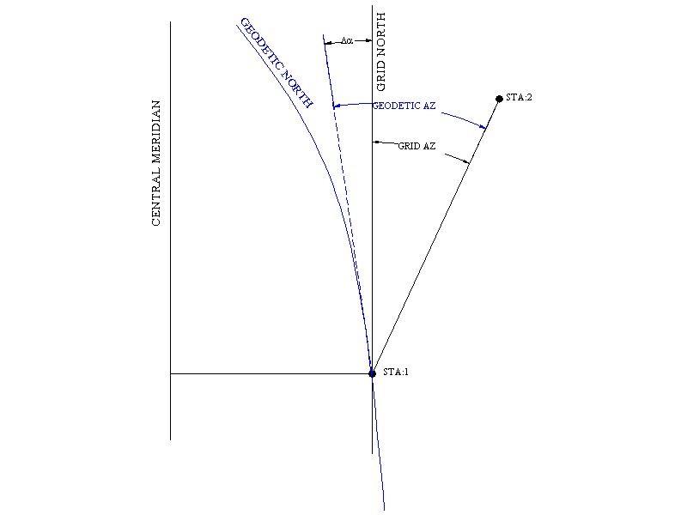

Figure .4- Grid Azimuth versus Geodetic Azimuth

Meridian convergence () is calculated using Eq 6.16 and is dependent on the Easting, along with the station’s latitude (ibid).

|  |  |  |
| --- | --- | --- |
| |  |  | | --- | --- | | where: | Eq . | |

The meridian convergence increases the further east or west the station moves from the zone’s central meridian. At the centre of the zone, meridian convergence is 0º, while for say, Calgary, which is on the eastern edge of zone 11, the meridian convergence is 2º19’09”. The Grid azimuth is over 2º smaller than the geodetic or true azimuth. For a azimuth to a jammer 500 metre away, this will translate into a 20.2 metre lateral difference, unless meridian convergence has been accounted for (in addition to declination) when translating the magnetic azimuth to grid azimuth. Grid azimuth is computed from magnetic azimuth by

|  |  |
| --- | --- |
| , | Eq 6.17 |
| where:  …is the azimuth to the jammer determined using Angle of Arrival (AOA) methods, |  |
| and  …is the meridian convergence. |  |

## Measurements

The NovAtel jammer geolocation system uses time differences of arrival (TDOA), which is the difference in time between the arrival of a signal from a specific transmitter (jammer) between two monitors (A & B). The two monitors are identical in hardware and data collected. We measure the TDOA by correlating time stamped I/Q Intermediate Frequency (IF) data collected at two bases. The time offset determined during the correlation contains both the time offset between the base and remote clock along with the time difference it takes for a signal leaving the transmitter to travel over the ground to reach the base and remote. In the sections below, we will discuss the TDOA measurement, its components and how it is measured.

## TDOA Measurements

|  |  |
| --- | --- |
|  | Eq . |

Where:

is the measured time difference of arrival using correlations between monitors A and B for a specific jammer (Tx) and reduced to the UTM mapping plane,

${Δρ}_{A,B}^{Tx}$ is the theoretical time difference of arrival on the UTM mapping plane,

${∆T}_{A,B}$ is the clock offset between base and remote, ${∆T}_{A,B}=T_{A}-T_{B}$

${dAntBias}_{A,B}^{Tx}$ is the TDOA bias due to antenna directivity, for monitors A and B and jammer (Tx) in nanoseconds,

$ε_{Terrain}$ is the error in range based TDOA computations due to errors in propagation velocity,

$ε_{Receiver}$ is the error in TDOA measurement due to receiver noise, and

$ε_{Multipath}$ is the error in TDOA measurements due to multipath.

The antenna bias for the receiver antennas (GNSS antennas) due to phase variations with azimuth and depending on the quality of the antenna is probably in the order of centimetres and can be ignored. The bias due to variations at the jammer may be more significant, especially if it is in a vehicle, and it can’t realistically be measured for an unknown jammer and vehicle combination (a possible research project).

The clock offset between base and remote can be resolved in real-time using the clock offset values estimated in the receiver (using the broadcast ephemeris and satellite clock models) or in post-mission processing using either a single difference computation over short baselines or using precise ephemeris and satellite clock data for more precision over longer baselines.

The main errors in the TDOA measurement are due to errors in propagation velocity over terrain, receiver noise and due to multipath. Of the three, the most significant in an open area is receiver noise, while in an urban area the multipath error can be significant.

### Theoretical Time Differences of Arrival

The theoretical TDOA based on ranges (we use l here to designate a range) is given by:

|  |  |
| --- | --- |
|  | Eq . |

where:

is the UTM distance from Monitor A to the jammer in metres, and

$l_{B}^{Tx}$ is the UTM distance from Monitor B to the jammer in metres.

The theoretical UTM distances are computed using the known coordinates of the base and remote along with the approximate or estimated coordinates of the jammer.

|  |  |
| --- | --- |
|  | Eq . |
| |  | | --- | |  | | Eq . |

where:

is the UTM easting and northing for Monitor A in metres,

$E_{B}, N_{B}$ is the UTM easting and northing for Monitor B in metres, and

${E^{Tx},N}^{Tx}$ is the UTM easting and northing for the jammer in metres. These are the unknown values we are determining.

### TDOA Measurements from Monitor A to Monitor B using Cross Correlation

As mentioned earlier in this document both the FireHose and the OEM628 Sprinkler collect IF I/Q data at various data rates and bit sizes. The FireHose outputs IF data at rates ranging from 2.5 MHz to 20 Msps and data sizes from 8 to 1 bits respectively. The OEM628 Sprinkler outputs IF data at 12.5 Msps and 1 bit. The FireHose can output data on L1 or L1 and L2, while the Sprinkler can be set to tracking the GPS and GLONASS L1 and L2 bands along with GPS L5 and LBAND, but the IF output can only be focused onto one of the bands being tracked (i.e. GPS L1). Both in-phase (I) and quadrature-phase (Q) data are available. The FireHose is capable of continuous data output while the Sprinkler outputs 5.2 ms of data every second and aligned to the receiver’s internal 1pps. The data from both receivers is placed in a time stamped packet. The time used is receiver time, which can be converted to GNSS (GPS) time using the calculated receiver clock offset.

|  |  |  |
| --- | --- | --- |
| |  | | --- | |  | | Eq . |

Time Difference of Arrival (TDOA) measurements can be measured by correlating IF data collected simultaneously at two or more stations. One TDOA can be formed for each pair of stations collecting data. The TDOA formed from the correlation can then be corrected for offsets between the stations clocks using Eq 6.18. The ratio of the correlation peak to the average correlation can be used test the validity of the correlation and thus the TDOA. The ratio threshold should be higher for 8 bit data and is typically 20 to 30, while for 1 bit data it should range from 3 to 7. If no jammer is present then no main peak will be present with a ratio larger than the threshold.

The steps for determining the TDOA from base-remote correlations is as follows:

1. Detect that a jammer is present using the AGC from both receivers. If the only one receiver has detected the jammer using AGC it is unlikely that a correlation will be present with a ratio above the threshold.
2. Pull IF I/Q data from both files for the first time the jammer is detected on both receivers. Typical data required for a civilian jammer is: between 4096 and 16384 I/Q pairs or 0.82 to 3.2 ms of data for the FireHose, and; 8192 to 32768 I/Q pairs or 0.66 ms to 2.6 ms for the Sprinkler. Since the correlation software uses FFT based cross correlation, the data quantity is a power of 2. The amount of data has been determined empirically but in principle should be long enough to see several chirp pulses but not so long as to create inaccuracies from unmodelled relative motion between the jammer and monitor stations. The data times from both files should be aligned to the same receiver time.

The monitor A set is full size (i.e. 8192) while the monitor B data set is reduced by the correlation search size. The correlation search size is computed by:

|  |  |  |
| --- | --- | --- |
| |  | | --- | |  | | Eq . |

Where

is the sampling frequency in samples per second,

$l_{A}^{B}$ is the length of the baseline between the two monitors A and B in metres,

$c$ is the speed of light in metres per second (299,792,458 m/s), and

${∆t}_{Max}$ is the largest expected time offset between base and rover (typically 100 ns).

In practice we typically use the longest baseline in the array as $l_{A}^{B}$ and round it up to the nearest 10 samples. The baseline length is used because of the nature of TDOA measurements. The absolute value of the TDOA cannot theoretically be larger than the baseline length between the observing stations. Noise and clock offsets between the monitors should be taken into account. A clock offset of 100 ns which is considered large here would account for 1 sample with the FireHose or 2.5 samples with the Sprinkler. So for a 500 m baseline and 100 ns maximum clock offset between monitors A and B using the FireHose (5 Msps), the correlation search size would be 20 rounded up from 17.7 samples. For the Sprinkler, the baseline would need a correlation search size of 50 rounded up from 44.2 samples. Therefore if the monitor A data set is 8192 samples long, then the monitor B data set should have be 8172 samples long for the FireHose or 8142 long for the Sprinkler when the maximum baseline length is 500m. In our processing we have been using 8000 samples for the rover data size.

An example of this is shown in the figure below. Monitor A is 200 samples long in this example and Monitor B is 160 samples long. The first and last 20 samples in Monitor B are padded with zeros before the arrays are cross correlated. Since the two arrays are synchronized in this example, the cross correlation would give us a maximum at 20 which is ½ of the search size.



Figure .5 – Example of Base Rover Arrays for Cross Correlation (Red=I, Blue=Q)

1. Cross correlate the two data sets with a routine designed for complex data (I and Q). A FFT based algorithm was used here with most of the computations done onboard a NVIDIA GPU using CUDA code. A CPU (Windows 7 and 3.6 GHz Xeon) only version was used for comparison and produced identical results; however the CPU implementation was about 1000 times slower than the GPU implementation.
2. Compute the ratio of the peak to the mean value. The ratio should be above the ratio tolerance selected. For the FireHose (8 bit data) this range should be 10 or higher and for the Sprinkler (1 bit data) it should be 3 or higher. The correlation is considered satisfactory if the ratio is above the tolerance. It is expected to have a higher ratio from data with more bit resolution.
3. A discriminator is used to interpolate the TDOA value between samples. See Section 6.4.2.1 for more details.
4. The output from the discriminator is converted to a TDOA (see Section 6.4.2.2 for examples) by:

|  |  |  |
| --- | --- | --- |
| |  | | --- | |  | | Eq . |

1. The TDOA at this point is an observation on the terrain and should be reduced to the ellipsoid and the UTM mapping plane using the methods described earlier in this chapter. Following their reduction they can then be introduced into a least squares to estimate the jammers coordinates (discussed in Chapter 7).

A few example data sets and their correlations are given below with data sets for both the FireHose from Petawawa and the Sprinkler from observations on Deerfoot in Calgary. The Petawawa data set was collected from a stationary civilian jammer located approximately midway between two FireHose systems. With the 8 bit data it is quite easy to see the correlation between the base and rover data sets.

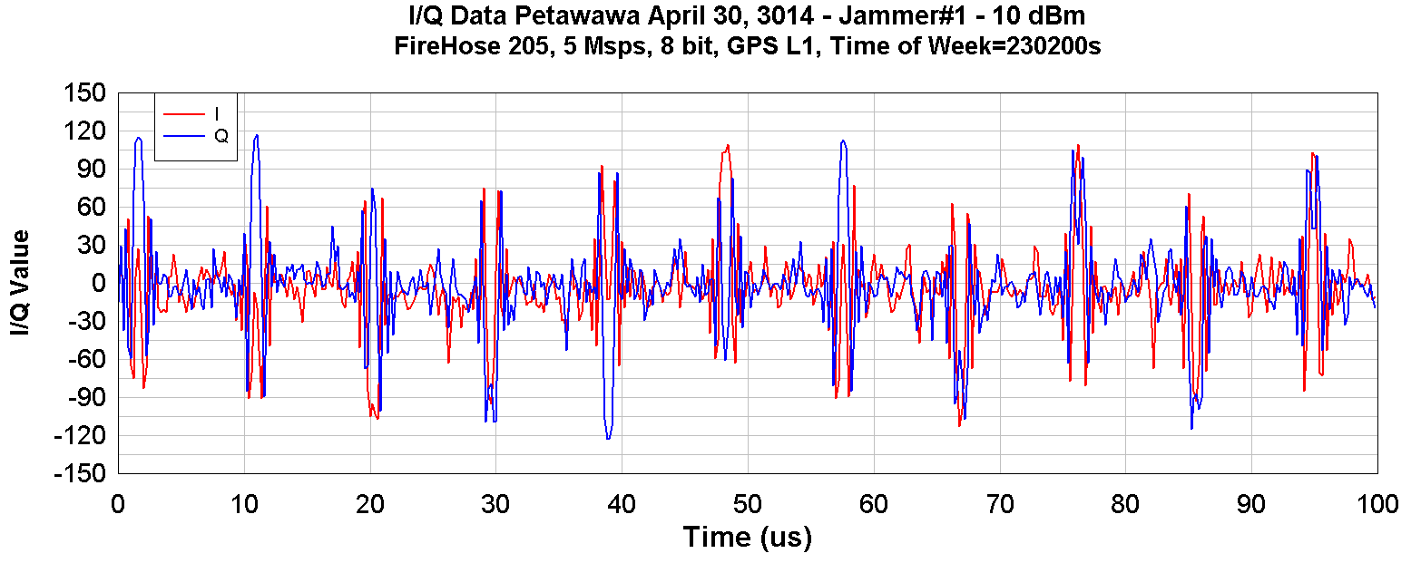

Figure .6 – I/Q FireHose Data, Receiver 205 – Petawawa 2013 – Jammer#1

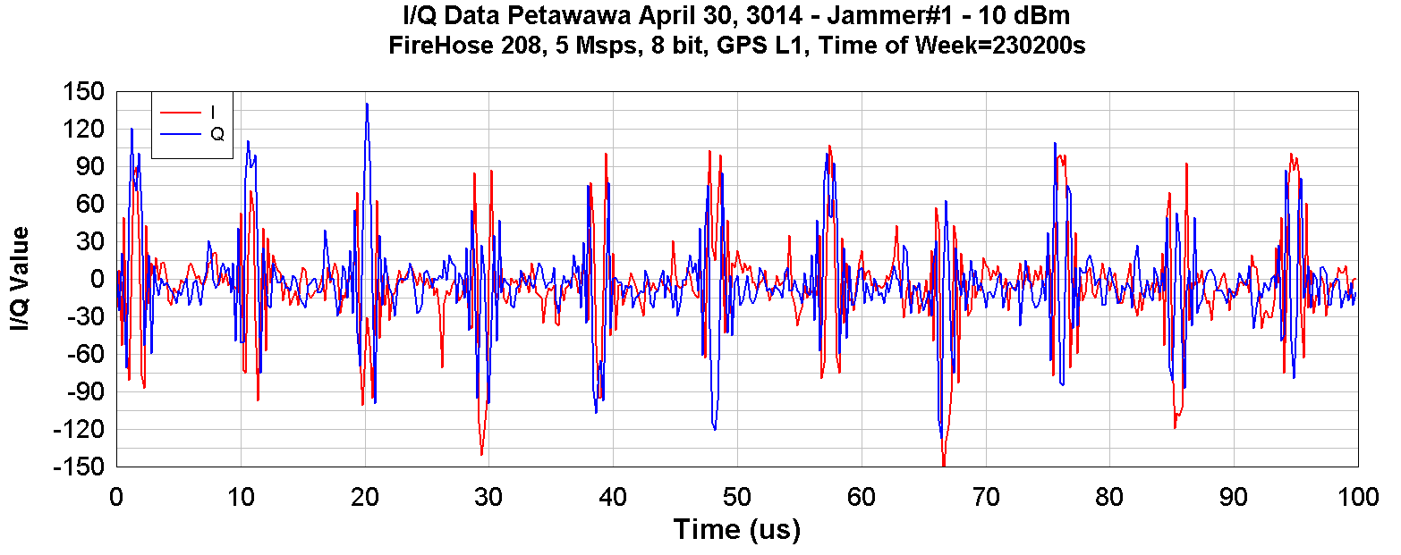

Figure .7 – I/Q FireHose Data, Receiver 208 – Petawawa 2013 – Jammer#1

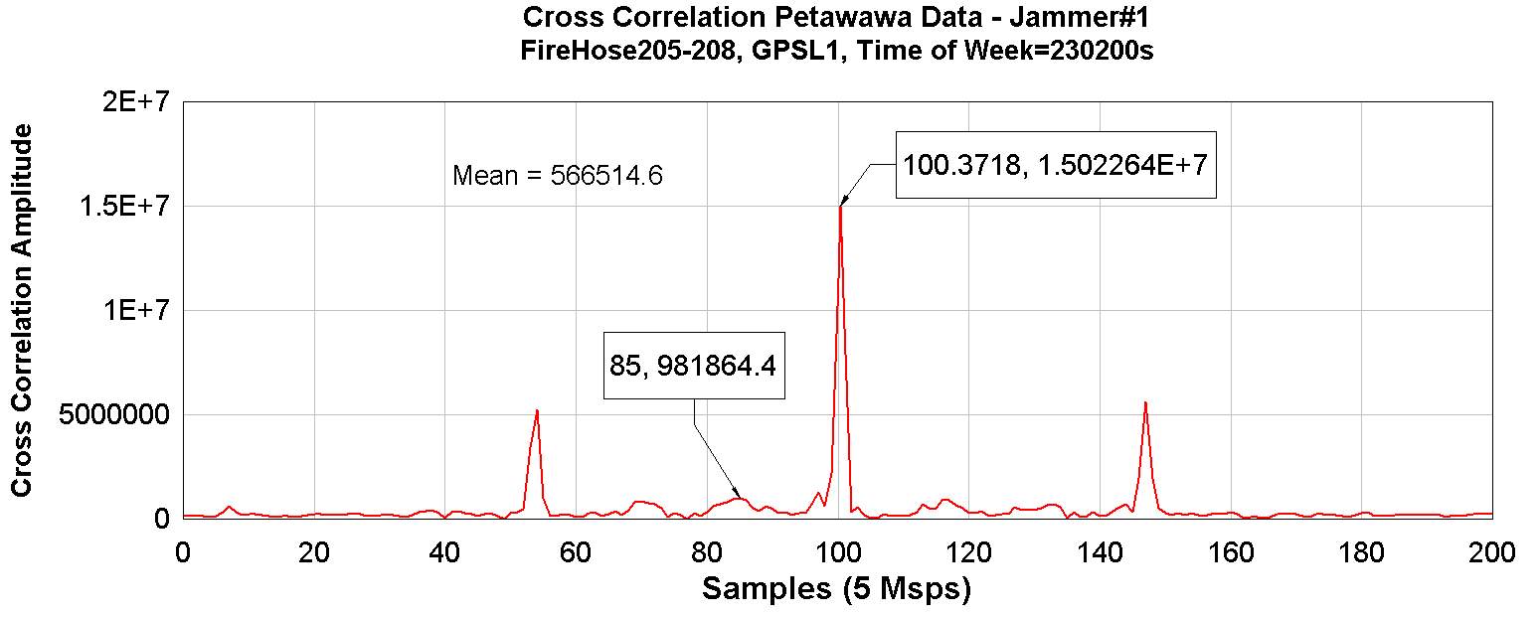

Figure .8 – Cross Correlation I/Q FireHose Data, Receiver 205-208 (200 Sample Search Size)

The Sprinkler data set was collected in September 2014 from Deerfoot Trail in Calgary. The jammer is a civilian jammer observed “in the wild” using two Sprinkler systems deployed either side of Deerfoot. The jammer was travelling approximately 105 kph southbound. It is difficult to see the correlation by visually comparing the base and rover data sets, though there are sections where the data is all 1s or -1s that can be seen regularly and this data correlates well.

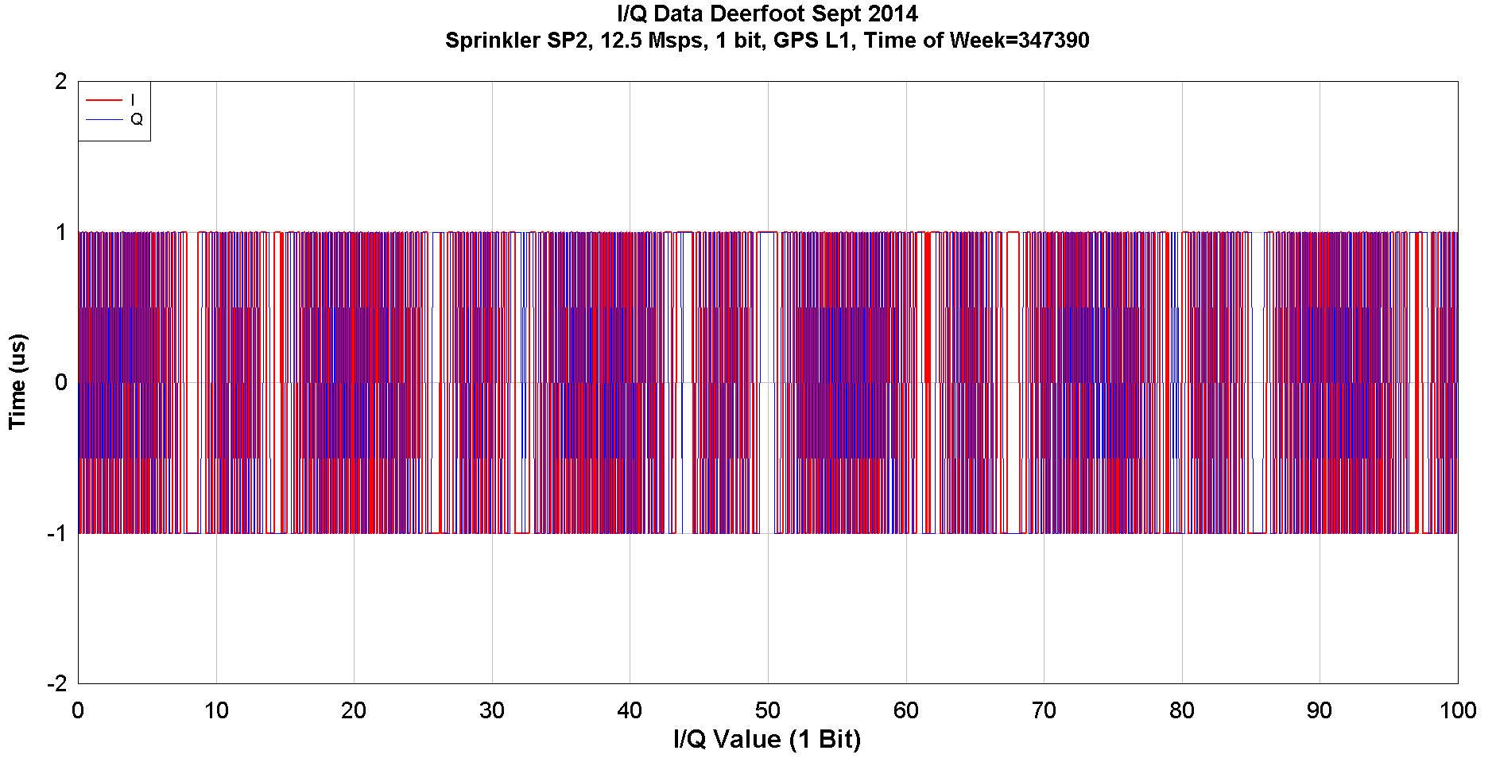

Figure .9 – I/Q FireHose Data, Receiver SP2 – Deerfoot Sept 2014

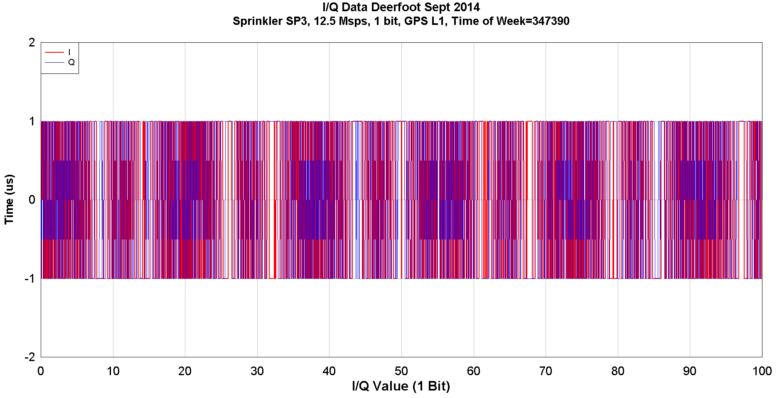

Figure .10 – I/Q FireHose Data, Receiver SP3 – Deerfoot Sept 2014

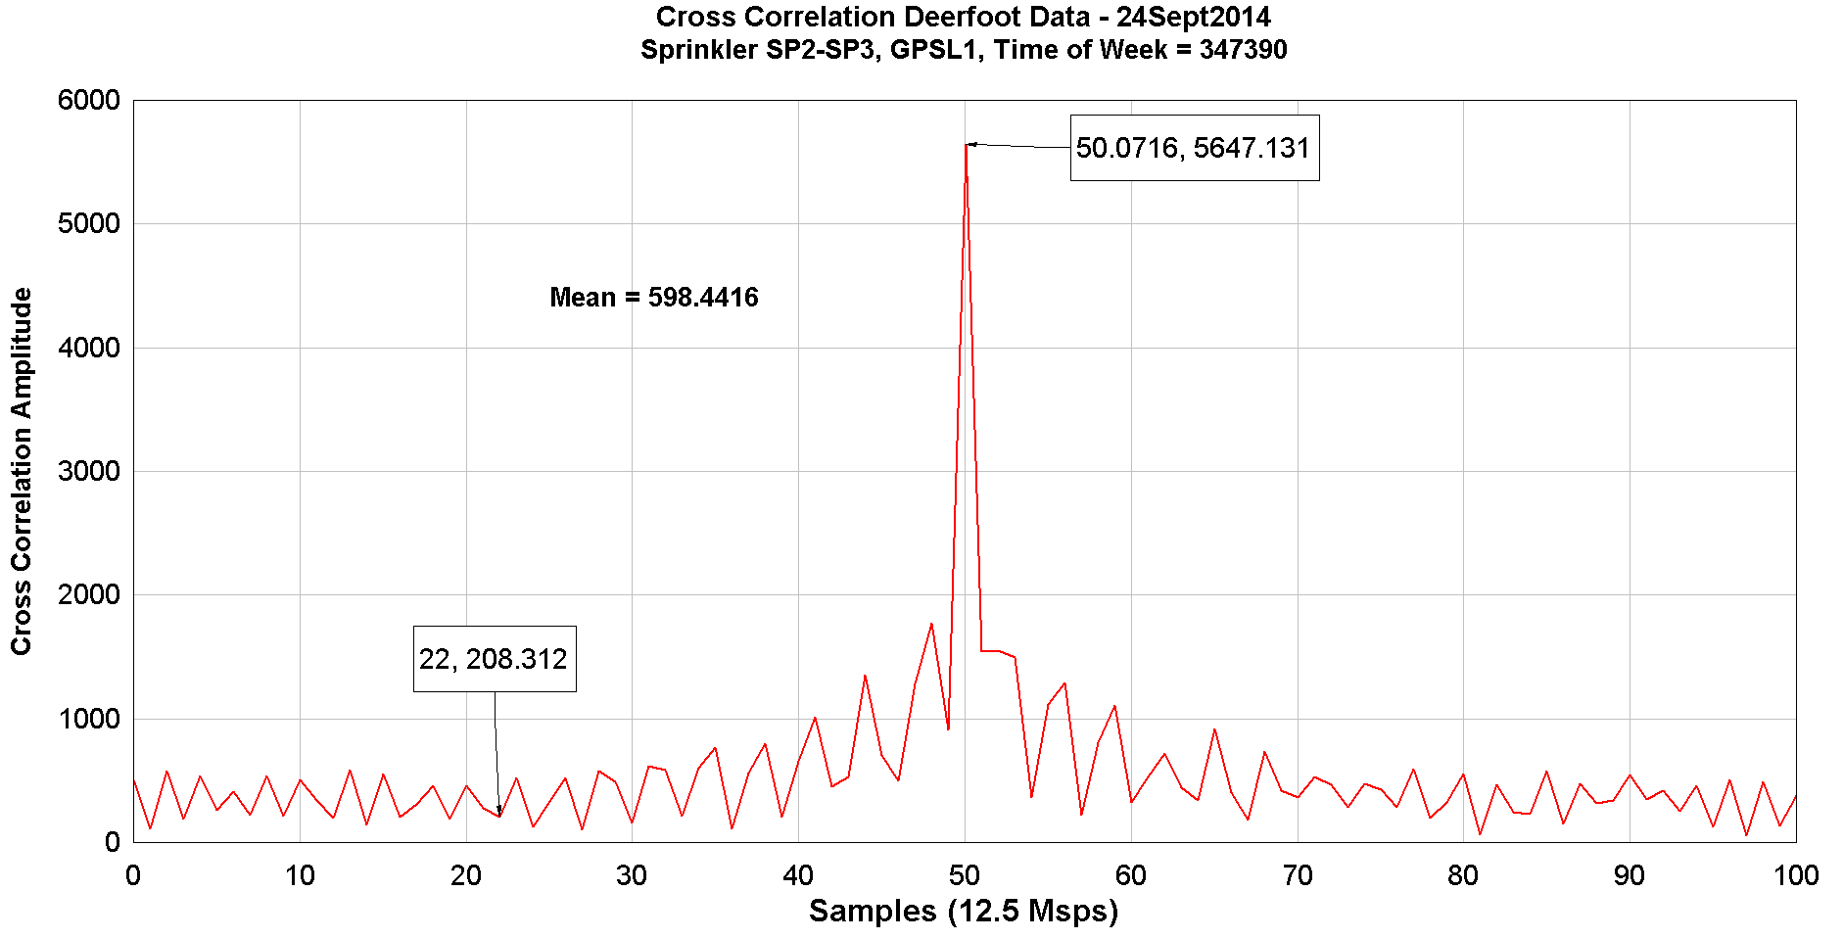

Figure .11 – Cross Correlation I/Q Sprinkler Data, Receiver SP2-SP3 (100 sample Search Size)

#### Discriminator

A discriminator function is used to interpolate the time from the cross correlation. If the data is sampled at 5 MHz they have a 2 µs separation between samples, and we can only expect to achieve on average 1 µs timing and 300 m TDOA accuracy if we used the maximum correlation (prompt or peak) value by itself. By using the early and late correlation values either side of the prompt in a discriminator function, we can refine that time offset.

The correlation discriminator is based on the assumption the actual correlation peak is located at the apex of a symmetrical triangle containing the early ($X_{e}$, $Y_{e}$), prompt ($X_{p}$, $Y_{p}$) and late ($X_{L}$, $Y_{L}$) correlation points. An interpolator could be based on any geometrical assumption or mathematical relationship between the samples and correlation values, but the symmetrical triangle seems to work well. The early, late and prompt points are the correlator values on three consecutive samples, with the time between samples being Ts or the inverse of the down-converted data’s frequency (2 µs = 1/(5 MHz)). The prompt point ($X_{p}$, $Y_{p}$) is the apparent maximum from the correlation, while ($X_{c}$, $Y_{c}$) is the interpolated maximum of the correlation, offset from the prompt point by a time offset ($T_{os}$). Figure 6.12 illustrates the locations of the early, prompt and late correlations along with their relationships to the actual correlation peak and time offset.



Figure .12 – Correlation Discriminator

Given the correlation values of $Y_{e}$, $Y_{p}$ and $Y_{L}$, along with the time interval between down-converted samples $T_{os}$, the actual correlation peak ($X_{c}$, $Y_{c}$) can be solved for using trigonometry (J.B. Schleppe Journal, 23Feb08).

For the case where $Y_{e}$ is less than $Y_{L}$, the values of the time offset $X_{c}$- $X_{p}$ can be found using:

|  |  |
| --- | --- |
|  | Eq . |

When is greater than $Y_{L}$, the time offset $X_{c}$- $X_{p}$ can be found using:

|  |  |
| --- | --- |
|  | Eq . |

Where:

or 80 ns for 12.5 MHz data.

The next two graphs show the interpolator at work on the two data sets presented in the previous sections. Figure 6.13 shows the interpolated cross correlation for the Petawawa data set along with the early, prompt and late data points. The ratio between interpolated peak and average cross correlations is 26.5, which is significantly higher than the ratio tolerance of 10. Figure 6.14 shows the interpolated cross correlation for the Deerfoot data set. The ratio between the interpolated peak and average correlation value for the Sprinkler data on Deerfoot is 9.4, again significantly higher than the Sprinkler ratio tolerance of 3.

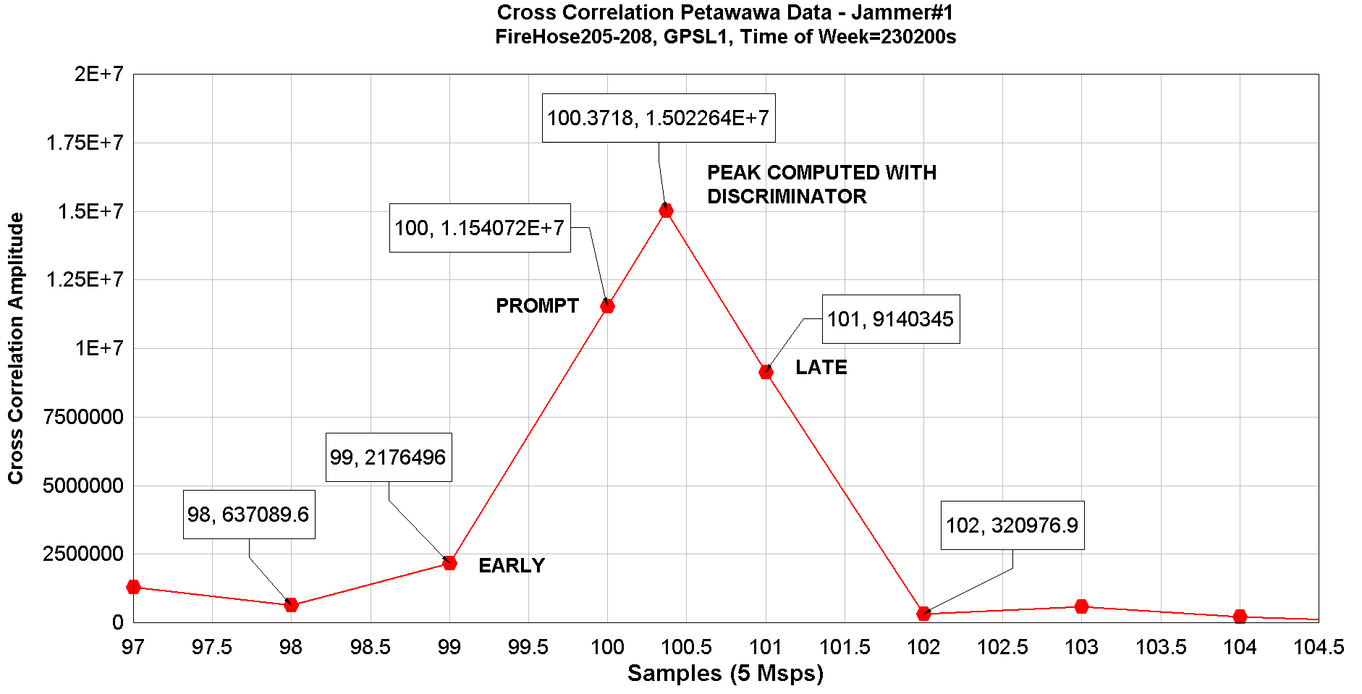

Figure .13 – Cross Correlation I/Q FireHose Data, Receiver 205-208 with Peak Interpolated using Discriminator

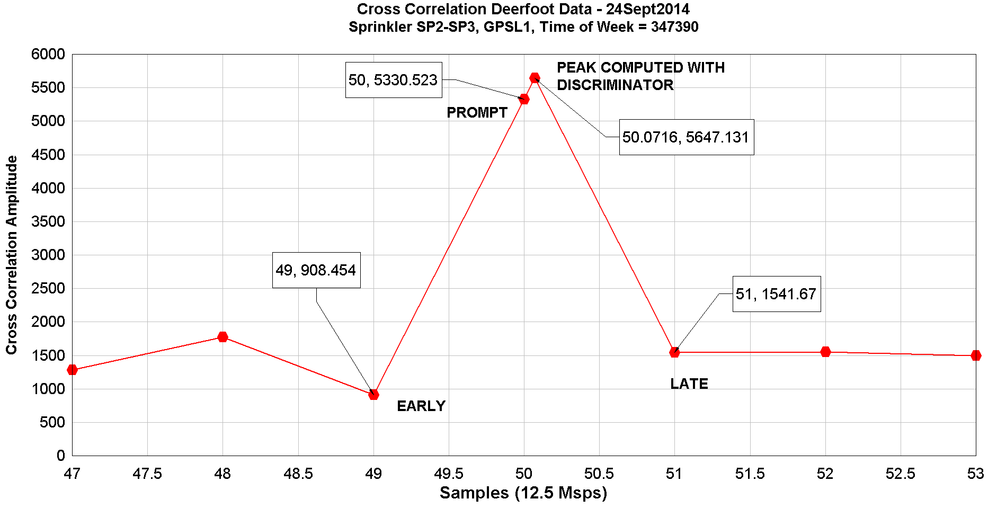

Figure .14 – Cross Correlation I/Q Sprinkler Data, SP2-SP3 with Peak Interpolated using Discriminator

#### Examples of Conversion from Cross Correlation to TDOA

Eq 6.4 is used to convert from the interpolated cross correlation in samples to a TDOA observation in seconds. The first example is for FireHose data collected at 5 Msps. For the FireHose correlation with a 200 sample search zone shown in Figure 6.13 the TDOA value is given by:

|  |  |  |
| --- | --- | --- |
| |  | | --- | |  | |  |

The second example is for Sprinkler data collected at 12.5 Msps. The TDOA from the Sprinkler correlation with a 100 sample search zone shown in Figure 6.14 is:

|  |  |  |
| --- | --- | --- |
| |  | | --- | |  | |  |

# Geolocation

## Using the TDOA for Geolocation

The positioning algorithm uses least squares with a parameterization for range differences based on UTM coordinates (Schleppe Journal, Page 124, 31May2010). Elevations are not considered unknowns since the typical monitor station geometry makes its estimation difficult. The monitor elevations are used for reduction of the observations down to the ellipsoid.

The observations are expressed as a parametric equation, where observations (l) are a function of the unknowns (x),

|  |  |
| --- | --- |
|  | Eq . |

The measured TDOA’s expressed as a function of the geometric TDOA’s is given in Eq 6.8 and repeated here for clarity:

|  |  |
| --- | --- |
|  | Eq . |

Where the measured TDOA, ${\overline{TDOA}}_{A,B}^{Tx}$ is expressed in metres and reduced to the UTM mapping plane (see Sections 6.1.1 and 6.2.3).

The observation equation for the corrected TDOA with respect to the ranges (l) from the jammer to the monitors and including the clock offsets is given by:

|  |  |
| --- | --- |
|  | Eq . |

Expressing the ranges as a function of the UTM coordinate gives us:

|  |  |
| --- | --- |
|  | Eq . |

Where () are the UTM coordinates of the monitor station A and ($N_{B},E_{B}$) are the UTM coordinates of monitor station B, and $\left(N^{Tx},E^{Tx}\right)$ are the UTM coordinates for the transmitter/jammer.

In least squares, the unknown values can be expressed as,

|  |  |
| --- | --- |
|  | Eq . |

Where:

is the adjusted unknown values,

$x^{0}$ are the initial values for the unknowns, and

$δ$ are the corrections to the unknowns.

The vector of unknowns contains the jammer’s (Tx) UTM coordinates (N, E). The clock offset is determined using the difference between the GNSS receivers clock offsets between base and remote:

|  |  |
| --- | --- |
|  | Eq . |

The TDOA model is non-linear and not explicit in x. In order to solve for the unknowns in least squares, the model must be linearized. The linearized model takes the form:

|  |  |
| --- | --- |
|  | Eq . |

Where:

is the observation residuals, and

$A$ is the design matrix, which provides the Taylor series relationship between the unknowns and observations.

The observations $l$ are the measured and corrected time difference of arrivals using correlations for the jammer between all of the stations,

$l=\left[\begin{aligned}\begin{matrix}{\overline{TDOA}}_{A,B}^{o} \\ {\overline{TDOA}}_{A,C}^{1} \\ ⋮ \end{matrix} \\ {\overline{TDOA}}_{B,C}^{n-1}\end{aligned}\right]$, where n = number of observations (n x 1)

The parametric least squares equation is used to solve for the corrections to the unknowns,

|  |  |
| --- | --- |
|  | Eq . |

Where:

is the design matrix of the unknowns (n x u),

$C_{l}$ is the covariance matrix of the observations (n x n), and

$w$ is the misclosure vector $f\left(x^{0}\right)-l$ (n x 1)

The design matrix A is:

|  |  |
| --- | --- |
|  | Eq . |

Taking the derivatives of the TDOA equation with respect to the jammer’s Northing and Easting yields a row (with 2 columns = 2 unknowns) of the design matrix for each combination of monitoring stations used to form the TDOA.

|  |  |
| --- | --- |
|  | Eq . |

A row will be added to the design matrix A for each TDOA measurement included in the least squares. If a “*summation of normals”* ( a sequential method) least squares method is used, the design matrix A would stay as a single row, with the N and U matrices formed one observation at a time as:

|  |  |
| --- | --- |
|  | Eq . |
|  | Eq . |
|  | Eq . |

The “*summation of normals”* method does ignore the correlations between the measurements in the covariance matrix of the observations, but typically we ignore this anyway.

There are two unknowns, requiring at least two observations (using 3 stations, i.e. ${\overline{TDOA}}_{A,B}^{Tx}$ and ${\overline{TDOA}}_{B,C}^{Tx}$) to solve for the unknowns. Moreover, the geometry of the transmitters is crucial to the solution of the jammer’s coordinates.

The covariance of the TDOA observations is approximated by a diagonal matrix, with a typical value empirically derived for the FireHose as:

|  |  |
| --- | --- |
|  | Eq . |

This is a simplification and perhaps the distance from the monitors to the transmitter as well as the number of data bits used should be taken into account when computing the TDOA covariance. However, limited testing so far with this simplification has worked well.

The observation equation is non-linear, so the solution will have to be iterated until the corrections to the unknowns $\hat{δ}$ are less than 0.01 m. The iteration is accomplished by updating the initial coordinates using the estimated coordinates until the absolute difference between adjusted and initial values is below the tolerance which in this case I 0.01 m. If the number of iterations go past 10 or 20 then the estimation should be rejected because it is not converging. This is quite common when using TDOA measurements outside of the monitor station perimeter, especially along the baseline projection beyond a monitor stations.

The covariance of the unknowns is:

|  |  |
| --- | --- |
|  | Eq . |

Residuals are necessary to evaluate the success of the adjustment and to identify problem observations. They can be estimated by:

|  |  |
| --- | --- |
|  | Eq . |

The *a posteriori* variance factor is useful for scaling the covariance of the unknowns as well as evaluating the validity of the observation weighting scheme. It is compute by:

|  |  |
| --- | --- |
|  | Eq . |

In the case of a “*summation of normals*”, we can compute the *a posteriori* variance factor by:

|  |  |
| --- | --- |
|  | Eq . |

The variance factor gives us an indication of the “optimism” of our observation weighting or will also indicate blunders present in the observations. A variance factor ${\hat{σ}}_{0}^{2}$ of 1 indicates the observation weighting is ideal. A value less than 1 indicates the weighting is pessimistic or the observation standard deviations should be reduced. A value greater than 1 indicates the weighting is optimistic and the observation standard deviations should be increase. It is especially useful for tuning a new system.

## Monitor Station Geometry and Jammer Location Accuracy

The location of the three or four monitor stations with respect to the jammer is a major factor in jammer position accuracy. The accuracy can be predicted using some of the least squares equations presented earlier. Given the proposed monitor station geometry and the observation variance, the theoretical positioning accuracy can be estimated for a grid of potential jammer coordinates. Contouring the semi-major axis of the error ellipse at each of the grid points gives us a contour plot of theoretical accuracy around the monitor stations.

The following information is required:

1. Proposed coordinates of the monitor stations ( at least 3)
2. Variance of the TDOA observations (2.8m)2
3. A grid of points to estimate the accuracy at, typically a 50 or 100 m spacing covering the monitor station network and extending several kilometres either side.

The covariance matrix for the accuracy analysis is estimated using the equation for the N matrix, Eq 7.11. At each grid point, the UTM coordinate is used the jammer position and the A matrix is formed using these grid coordinates along with the known (or proposed) monitor station coordinates.

The covariance matrix of the unknowns ${\hat{C}}_{x}$ is formed by inverting the N matrix, as in Eq 7.15.

The ${\hat{C}}_{x}$ matrix consists of the following elements:

|  |  |
| --- | --- |
|  | Eq . |

where:

is the predicted variance of the grid points northing,

$σ_{E}^{2}$ is the predicted variance of the grid points easting,

$σ_{N,E}$ is the covariance between the grid points easting and northing.

These elements can be used to compute an ellipse shaped confidence region whose parameters are computed by:

|  |  |
| --- | --- |
|  | Eq . |
|  | Eq . |
|  | Eq . |

where:

a is the semi-major axis of the confidence region at 39% probability level,

b is the semi-minor axis of the confidence region at 39% probability level, and

$θ$ is the azimuth of a.

To bring the 39% (2D) probability level to 95%, the ***a*** and ***b*** values should be multiplied by 2.45.

Using the principles discussed here, the predicted accuracy for jammer positioning at the Petawawa site are shown below.

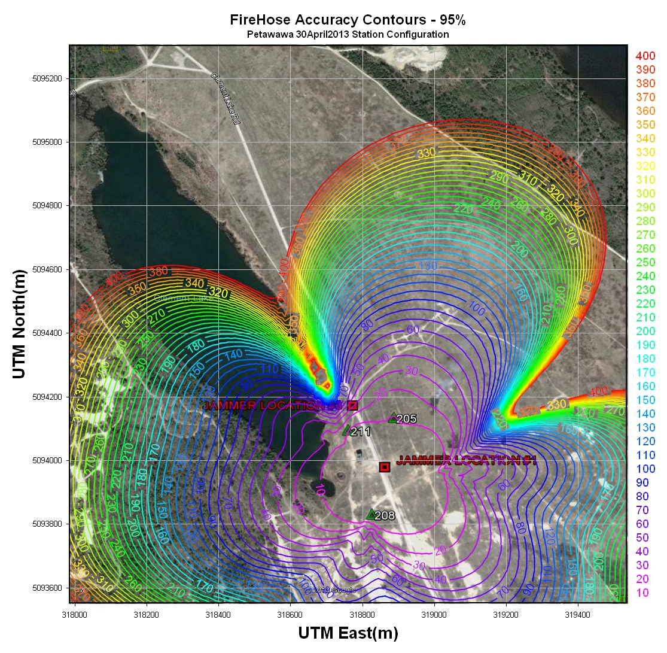

Figure .1 – Accuracy Contours (metres) for Petawawa – March 2013

Figure 7.1 shows how the predicted accuracy of the jammer location varies over the test area. Within the monitor station array (205, 208, 211, 212 (under the R in Jammer)) the predicted positioning accuracy is 10 m. Outside of this area the accuracy ramps up to 400m over a distance of 100 m in some areas. The areas of worse accuracy are those in a line projected beyond the monitor station baselines, for example north of 211 along the reverse azimuth to 208. This underscores the point that the monitor stations should be spaced as far apart as possible, so long as they can all receive the jammer everywhere within the array.

A few examples of accuracy contours for different monitor station geometries are shown below. Both plots were computed using a TDOA observation accuracy of 3.8 m (typically used with the Sprinkler). The first configuration is a north-south baseline configuration with all 4 monitor stations along a line. The stations are spaced 300 m apart and the maximum spread for station 1 to 4 is 900m. An important design decision is to make sure that the jammer is received by at least 3 of the 4 stations. This baseline configuration would be suitable for areas either side of the baseline but not along it, especially along the projections north or south. It also weakens significantly in the corners north and south of the baseline. This configuration would be used if you could not place a station east or west of the baseline.

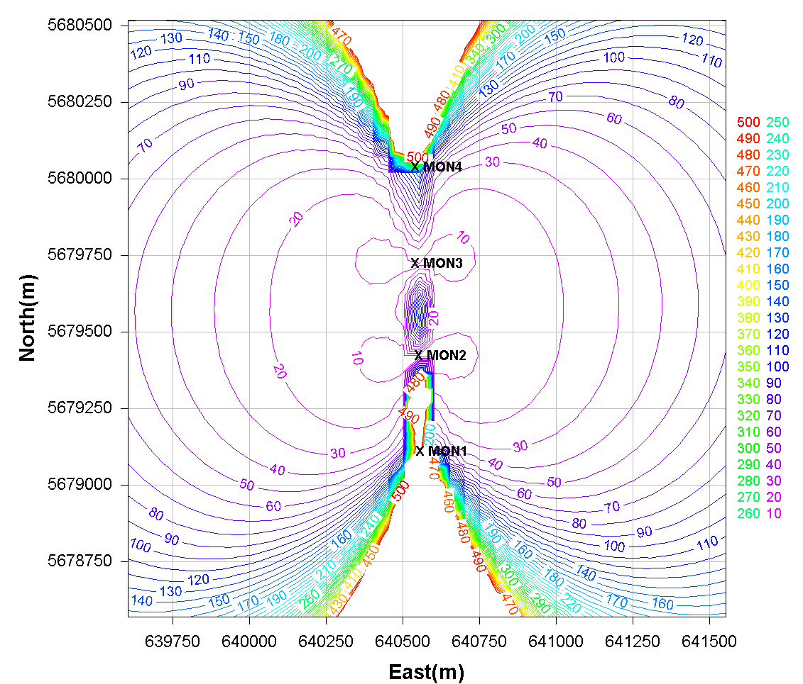

Figure .2 – TDOA Accuracy Pre-Analysis – 4 Stations North to South with 300 m Separation

The second configuration is a square configuration with station spacing of 650 m. The diagonal distance here is about 920 m which gives it a comparable maximum spread as the vertical configuration above. The square configuration provides the best overall accuracy for the 2 km square area shown in the graph. Accuracies degrade predictably outside of the array and don’t spike along the projections of any of the baselines. Accuracy inside the array is certainly better than the vertical array. This is the ideal configuration from an accuracy point of view if the jammer is or will be inside the array. It is interesting to compare Figure 7.1 for Petawawa with the ideal square configuration in Figure 7.3. At Petawawa the stations were situated in a rough square around the jammer. As it turns out the northern end was narrower than the southern end resulting in the extremely poor accuracies to the north of the array, much like seen in the vertical array. This underscores the care required when placing the monitor stations.

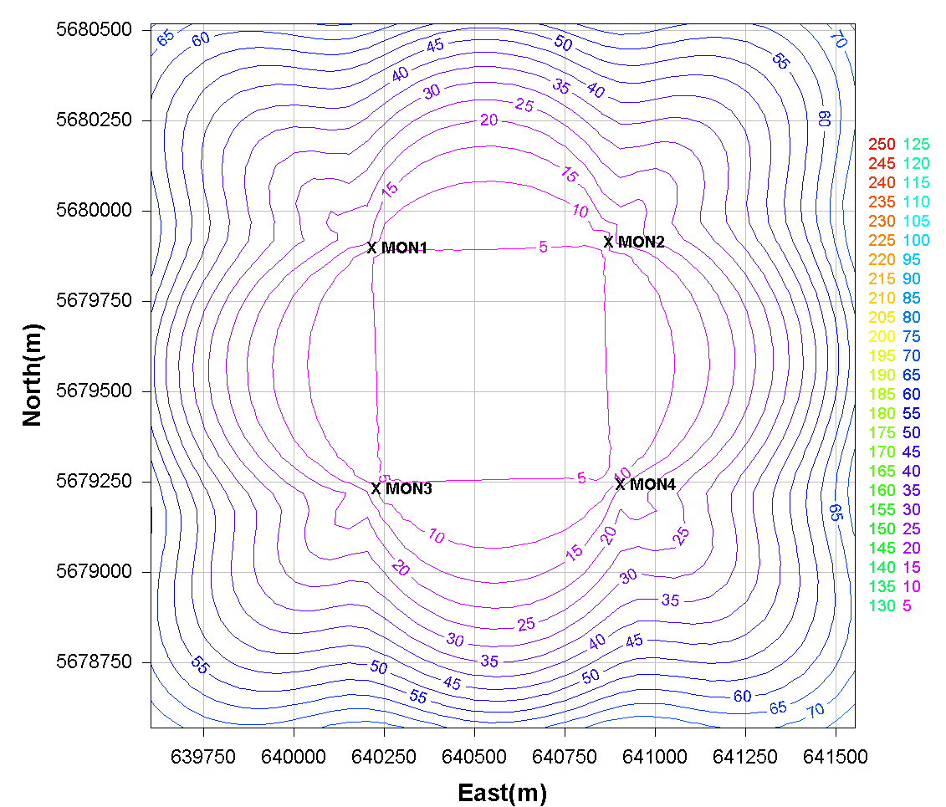

Figure .3 – TDOA Accuracy Pre-Analysis – 4 Stations in a Square with a 650 m Separation

## Geolocation Test Results

Several jammer geolocation tests have been conducted with the equipment and methods described herein. D18494 describes geolocation results of 5 civilian jammers at CFB Petawawa in March-April 2013. Summarized in the table below are the results from the Petawawa test using 4 – FireHose receivers as monitors. The geolocation results were compared against the test vehicle positions obtained using a DAGR. For a full description of the test and results please read D18494 in DSTS.

Table .1 – FireHose Jammer Location Errors – Static Location #1 – 30 April 2013

|  |  |  |  |  |  |  |  |
| --- | --- | --- | --- | --- | --- | --- | --- |
| **Jammer** | **Transmit Power (dBm)** | **Mean Position Error (m)** | **Position Standard Deviation (m)** | **Mean Northing Error (m)** | **Northing Standard Deviation (m)** | **Mean Easting Error (m)** | **Easting Standard Deviation (m)** |
| 1 – F15 | 10 | 5.96 | 0.44 | 5.64 | 0.46 | -0.49 | 0.65 |
| 1 – F15 | 7 | 6.56 | 0.41 | 6.31 | 0.38 | -1.68 | 0.68 |
| 1 – F15 | 4 | 6.64 | 0.46 | 6.37 | 0.48 | -1.74 | 0.33 |
| 1 – F15 | 1 | 6.31 | 0.33 | 6.19 | 0.34 | -1.15 | 0.33 |
| 2 – GJ6 | 10 | 7.07 | 0.84 | 7.05 | 0.86 | -0.47 | 0.34 |
| 2 – GJ6 | 7 | 7.78 | 0.39 | 7.05 | 0.47 | 3.23 | 0.57 |
| 2 – GJ6 | 4 | 7.22 | 0.56 | 6.31 | 0.54 | 3.48 | 0.46 |
| 2 – GJ6 | 1 | 6.42 | 0.81 | 6.18 | 0.83 | -0.53 | 1.67 |
| 3 – L1L2 | 10 | 21.58 | 3.30 | 20.84 | 3.27 | 4.41 | 3.51 |
| 3 – L1L2 | 7 | 9.60 | 2.84 | 8.83 | 2.92 | -2.45 | 2.77 |
| 3 – L1L2 | 4 | 18.50 | 2.98 | 18.44 | 2.99 | 1.37 | 1.59 |
| 3 – L1L2 | 1 | 27.65 | 7.53 | 27.03 | 7.41 | 4.81 | 3.56 |
| 4 – GP4000 | 10 | 6.39 | 1.45 | 3.81 | 2.03 | -4.76 | 1.26 |
| 5 – GP5000 | 10 | 3.94 | 1.37 | 3.69 | 1.65 | -0.76 | 0.68 |
| 5 – GP5000 | 7 | 4.52 | 1.03 | 3.76 | 1.51 | -2.17 | 0.64 |
| 5 – GP5000 | 4 | 4.15 | 0.49 | 1.79 | 1.02 | -3.61 | 0.44 |
| 5 – GP5000 | 1 | 4.21 | 0.52 | 2.64 | 1.03 | -3.10 | 0.62 |

The static results from Petawawa obtained using the TDOA correlation techniques described herein are capable of positioning 4 of the 5 civilian jammers to within 8 metres.

Dynamic results from Petawawa are shown in the next table. These were collected with the jammers mounted in a vehicle moving 20 kph and 50 kph. Jammer geolocation results within 250 m of the array were below 8 m when compared against the time tagged DAGR positions.

Table .2 – Jammer Location Errors – 250 m from Centre of Array – Dynamic Runs

|  |  |  |  |  |  |  |
| --- | --- | --- | --- | --- | --- | --- |
| **Jammer** | **Position Error (m)** | **Position Standard Deviation (m)** | **Northing Mean Error (m)** | **Northing Standard Deviation (m)** | **Easting Mean Error (m)** | **Easting Standard Deviation (m)** |
| 1 – F15 | 5.6 | 3.8 | 4.5 | 3.7 | -1.6 | 3.0 |
| 2 – GJ6 | 4.9 | 2.9 | 1.8 | 3.5 | 2.3 | 3.4 |
| 3 – L1L2 | 5.7 | 3.8 | 0.1 | 5.2 | 0.3 | 4.5 |
| 4 – GP4000 | 4.8 | 3.6 | 2.6 | 4.0 | -0.6 | 3.5 |
| 4 – GP4000 In Vehicle | 6.2 | 4.3 | 3.6 | 5.1 | -1.1 | 4.1 |
| 5 – GP5000 | 7.3 | 9.4 | 4.1 | 6.2 | -0.2 | 9.3 |
| 5 – GP5000 In Vehicle | 7.2 | 4.3 | 5.2 | 5.0 | 1.1 | 4.1 |

Unfortunately a similar test was not possible with the Sprinkler hardware in 2014. Instead we set out to capture the position and video of a civilian jammer along Deerfoot Trail north of Calgary. An area was selected just south of Country Hills Blvd where easy and safe access either side of Deerfoot was available. Four Sprinkler units were setup, with three units monitoring on the west side of Deerfoot and the fourth setup on the east side. Also setup on the east side of Deerfoot was a truck equipped with a fifth unit connected to a laptop which was used to monitor AGC’s. When a jammer was spotted while monitoring the AGC’s, video was captured.

Figure 7.4 shows the location of the Sprinkler array along with the location of the monitoring truck along Deerfoot Trail. The red dots along Deerfoot are positions of a civilian jammer recorded at approximately 18:29 on the 24th of September 2014. The AGC was able to detect the jammer over an 800 m distance and a plot of the peak frequency versus time shown in Figure 7.5 helps us identify the jammer as a civilian jammer with a 58 kHz chirp repetition rate. This jammer does not appear to be one of the models seen during the Petawawa tests in 2013.

Zooming into the Deerfoot area in Figure 7.6 shows the positions of the jammer relative to the camera for 18:29:32.5MDT and 18:29:33.5MDT. After synchronizing the video with GPS time (by capturing video of the Sprinkler real-time display) the probable vehicle carrying the civilian jammer is shown in Figure 7.7 and Figure 7.8. The conclusions from this test are that it is possible to geolocate a civilian jammer with a good accuracy using only the 1 bit data from the Sprinkler.

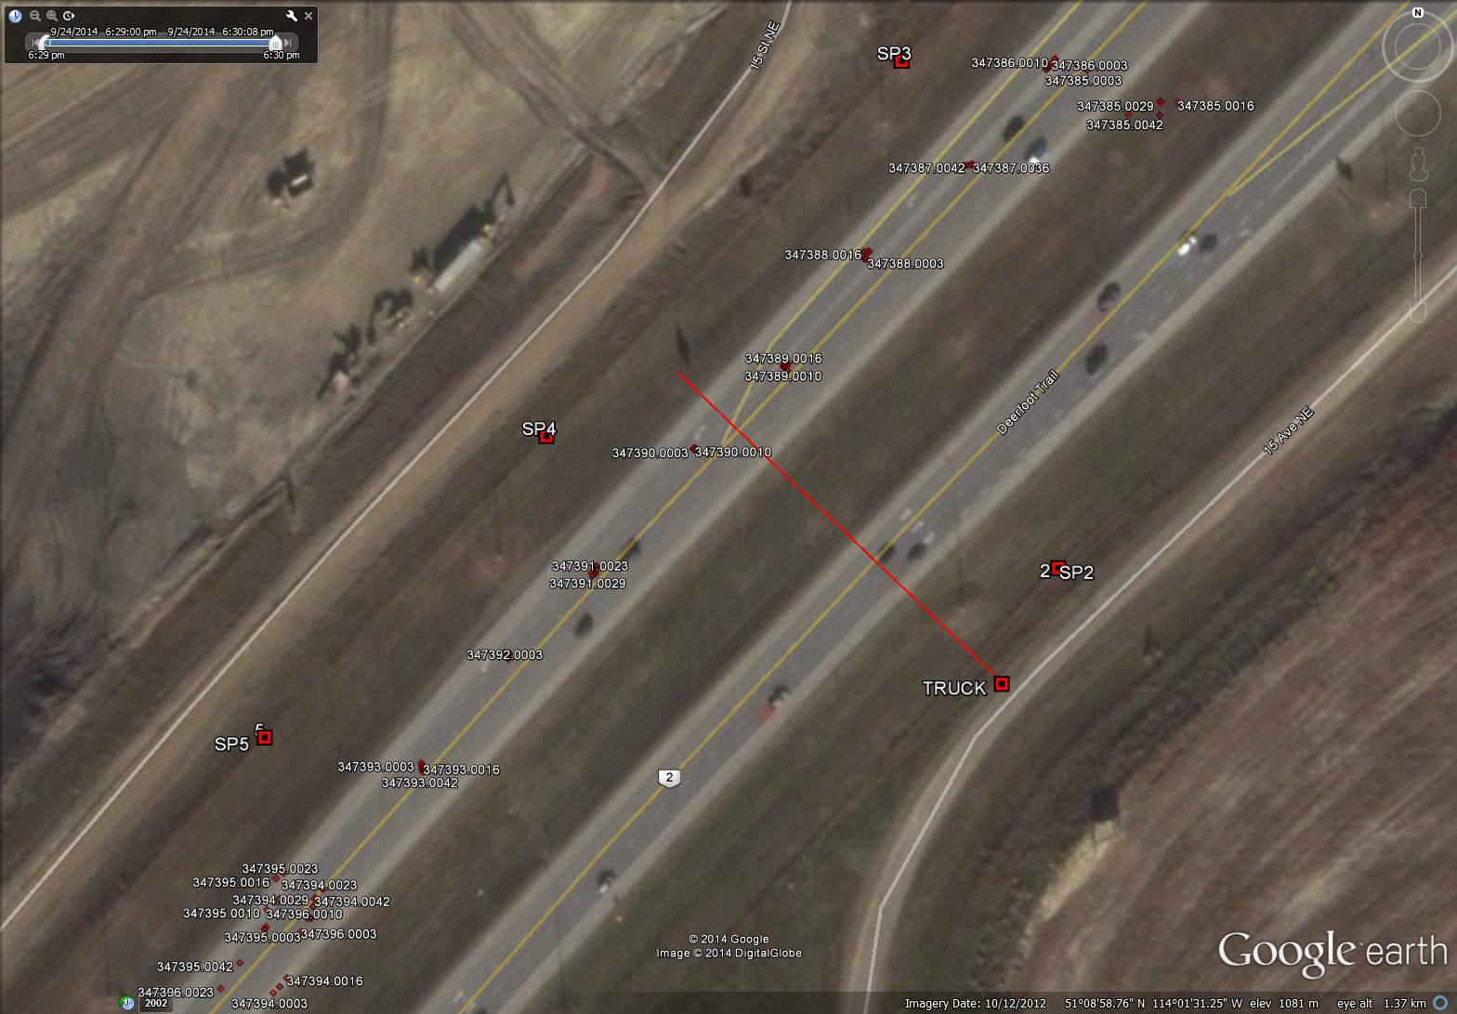

Figure .4 – Sprinkler Monitor Array along Deerfoot Trail – 24 September 2014

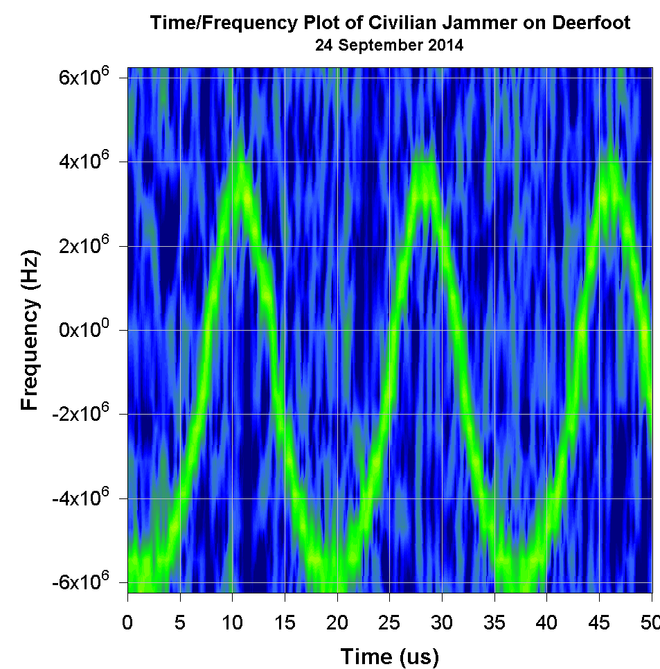

Figure .5 – Deerfoot Jammer Peak Frequency versus Time

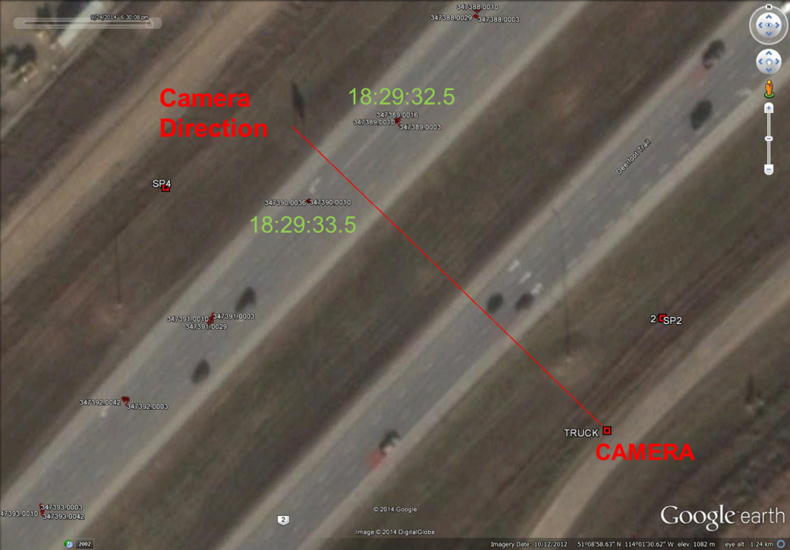

Figure .6 – Zoom in of Deerfoot Jammer and Camera Locations

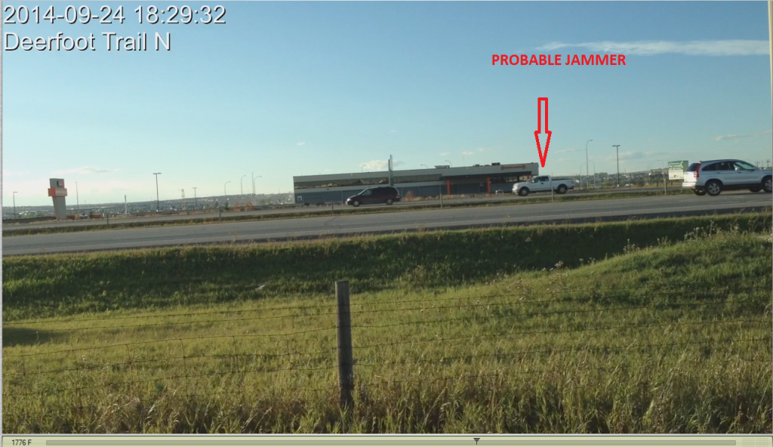

Figure .7 – Probable Picture of Jammer at 18:29:32.5 MDT

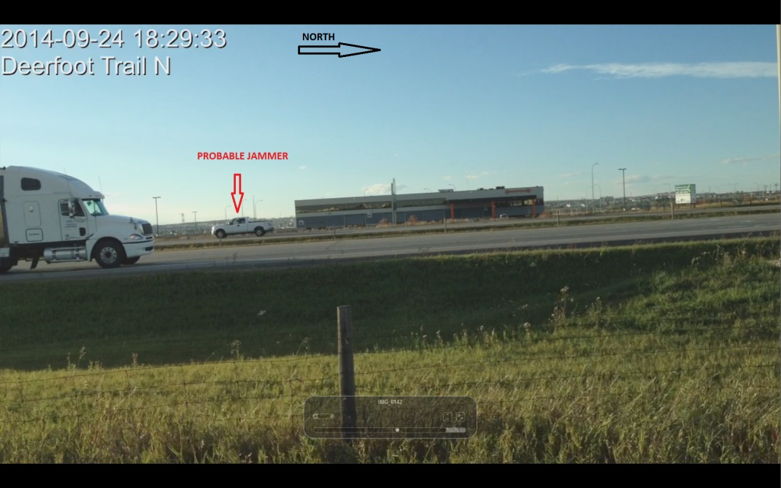

Figure .8 – Probable Picture of Jammer at 18:29:33.5 MDT

# Conclusions and recommendations

The objective of this research was to gain a better understanding of jammers, their detection and their geolocation. Those objectives were met during this project. At least five different civilian jammers were tested during the research. Methods of detection using the AGC from Novatel’s receivers was developed and successfully implemented in real-time. Tests on NovAtel’s rooftop showed at least 10 jamming events per week in the nearby area, all easily detected using methods explained in this report. Three geolocation tests were conducted with increasing proficiency. Jammer geolocation accuracies to better than 10 metres were achieved using post-processing software developed within this research project. In addition to the research on jammers, we also developed other projects to aid in jammer positioning including: use and steering of CSAC; use of GPU’s to dramatically speed up FFT processing and correlations; development of the IF data output feature on the MINOS6 and setting up the framework for further exploitation of this feature in the MINOS7.

Despite these successes this research has just scratched the surface of the effort to commercially develop a jamming detector and geolocation system. The system developed here was suitable for single civilian chirp jammers, but as jammers become more common place there will be more incidences with multiple jammers.

## Recommendations

Recommendations include:

1. Implement the Sprinkler IF I/Q onboard the OEM7 family of receivers. This technology would allow the OEM7s to be used for jammer detection and geolocation as well as other applications that our clients dream up.
2. Continue to support the FireHose and Sprinkler research efforts of clients such as DRDC, FOI, NavSys.
3. Continue to develop processing applications using GPUs to speed up processing. The use of GPUs in this research resulted in a dramatic increase in correlation processing speeds.
4. If further investigation into geolocation of jammers is warranted then:
   1. Further develop the jammer identification and tracking methods to allow geolocation of multiple jammers
   2. Investigate the use of Kalman filters over least squares for the geolocation.
   3. Conduct a controlled field trial with multiple jammers running simultaneously.
   4. Investigate methods of minimizing the effect of multipath on the observations
   5. Integrate a video camera into the data collection system with emphasis on automatic camera trigger base on AGC’s and camera system time synchronization.
   6. Look into developing a real-time system using Wi-Fi to share data with a central control station.

## Limitations

Limitations of this research and geolocation method include:

1. The TDOA correlation method is suitable for:
   1. civilian chirp jammers and wide band random noise jammers such as NEAT.
   2. Spoofers, so long as the monitor receivers are not spoofed
2. The TDOA correlation method is not suitable for:
   1. Multiple jammers
   2. Areas of high multipath such as urban centers
   3. Narrow band and continuous wave (CW) jammers
   4. Weak jammers that only jam within a few metres.

To track multiple jammers it is better to use a chirp modelling and tracking method such as P. Fenton’s covered in this document or the method discussed in Mitch et al. 2013. An Angle of Arrival system capable of measuring to multiple sources is another method that could be used for multiple jammers.

# References and APPLICABLE DOCUMENTS

## Non-NovAtel Documents

Davis, R.E., F.S. Foote, J.M. Anderson, E.M. Mikhail (1981), **Surveying Theory and Practice**, Fifth Edition, McGraw-Hill Inc., New York, 1981.

Guinand, Paul, A. Hunt, D. Paskovich, C. Benoit, J. Lodge (2012), “GPS Chirp Jammers: Measurement and Detection”, 30th AIAA International Communications Satellite System Conference (ICSSC), (Ottawa, Canada), September 2012.

Heiskanen, W.A., and H. Moritz, **Physical Geodesy**, Institute of Physical Geodesy, Technical University Graz, Austria, 1979.

ITU-R SM.2211, **Comparison of Time-Difference-of-Arrival and Angle-of-Arrival Methods of Signal Geolocation**, International Telecommunication Union, Radiocommunication Sector, June 2011.

Mitch, Ryan H., R.C. Dougherty, M.L. Psiaki, S.P. Powell, B.W. O’Hanlon, J.A. Bhatti and T.E. Humphreys (2011), “Signal Characteristics of Civil GPS Jammers”, Proceedings of the ION GNSS Meeting, (Portland OR), Institute of Navigation, September 2011.

Mitch, Ryan H., M.L. Pasiaki, B.W. O’Hanlon, S.P. Powell and J.A. Bhatti (2012), “Civilian GPS Jammer Signal Tracking and Geolocation”, Proceedings of the ION GNSS Meeting, Institute of Navigation, September 2012.

Mitch, Ryan H., M.L. Psiaki, S.P. Powell and B.W. O’Hanlon (2013), “Signal Acquisition and Tracking of Chirp-Style GPS Jammers”, Proceedings of the ION GNSS Meeting, Institute of Navigation, September 2013.

Nav Canada GPS Jamming Test Plan, Petawawa, Apr 30-May1, 2013, Revision 2.

Thompson, Ryan J., E. Cetin, A.G. Dempster (2011), “Detection and Jammer-to-Noise Ratio Estimation of Interferers Using the Automatic Gain Control”, Proceedings of the International Global Navigation Satellite Systems Society Symposium 2011 (New South Wales, Australia), November 2011.

Symmetricom Document No. 098-00055-000, SA.45s Chip-Scale Atomic Clock User’s Guide, Rev. A, 21 July 2011.

US Army Corp of Engineers 1996, Handbook of Transformation of Datums, Projects, Grids and Common Coordinate Systems, TEC-SR-7, Document# 19960425034

## NovAtel Documents

D11471 – M6 Module Conceptual Design – AGC, Revision 0B, 25 October, 2007

D16100 – Garden Hose Prototype Development Report, Revision 0B, 3 July 2012

D17063 – Garden Hose Prototype Upgrades Report, Revision 0B, 3 July 2012

D17088 – NovAtel Digital GNSS Antenna Test Setup and Interfacing, Revision 0H, 14 January 2013.

D18058 – Chip Scale Atomic Clock PLL API, Revision 0B, 15 April 2013.

OM-20000095 – GPS-702-GG, GPS-701-GG and GPS-702-GG-N Users Guide, Revision 2, 11 August 2011.

D18494 – Jammer Geolocation using the NovAtel FireHose at CFB Petawawa April 30-May1 2013, Rev 0B, 6 August 2013.

D19080 – OEM6 Family ICD for RAWIQ Data – Project: Sprinkler, Revision 0D, 15 July 2014

D19432 – Control Display Utility for NovAtel R&D Project: Sprinkler, Revision 0A, 17 June 2014

D19779 – Using the Prototype NovAtel IQ Data Message (Sprinkler) to Detect and Geo-located a Detect and Geo-locate a Jammer “In the Wild”, Revision 0A, 27 October 2014

# AppendixA – Alternate method of computing UTM Scale Factor for Distances

The scale factor to reduce ranges from the ellipsoid ($l_{E}$) to the UTM mapping plan is given by:

|  |  |
| --- | --- |
|  | Eq . |

With

|  |  |
| --- | --- |
|  | Eq . |

and

|  |  |
| --- | --- |
|  | Eq . |
|  | Eq . |

The is UTM scale factor for the central meridian and it 0.9996. The ${fE}_{UTM}$ UTM false easting is used to prevent UTM easting coordinates from being negative and is typically 500,000 m.

The UTM scale factors sf36 and sf6 are given by:

|  |  |
| --- | --- |
|  | Eq . |
|  | Eq . |

with,

|  |  |
| --- | --- |
|  | Eq . |

Where *a* is the semi-major axis of the ellipsoid (typically 6378135.0 m) and M is the meridian radius of curvature given in Eq 6.3, and

|  |  |
| --- | --- |
|  | Eq . |

The mean latitude $∅_{m}$ obtained by averaging the latitude at stations A and B and the eccentricity squared ($e^{2})$ of the ellipsoid obtained from the ellipsoid semi-major (***a***) and semi-minor axis (***b***) as shown in Eq 6.5.